|  |
| --- |
| Marree-Innamincka District Plan |
| 2024 – 2026 |

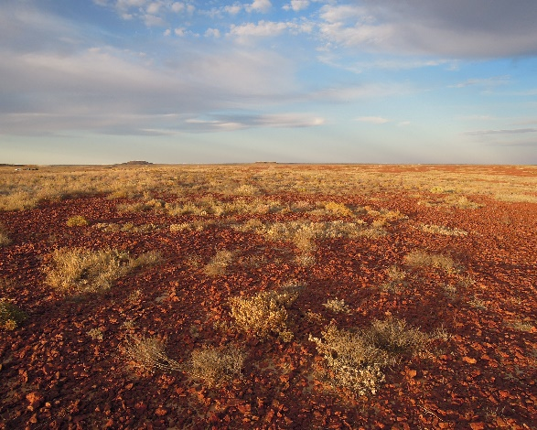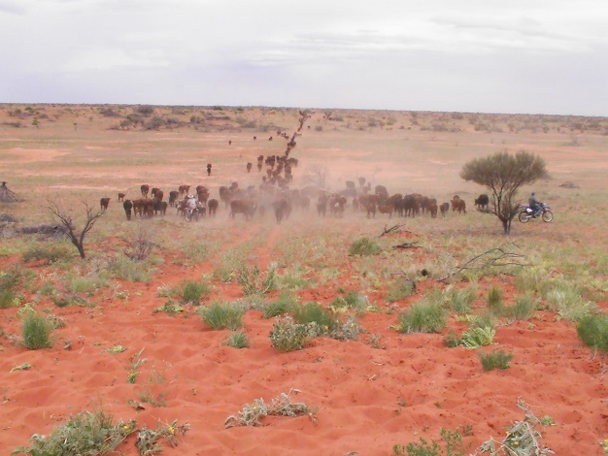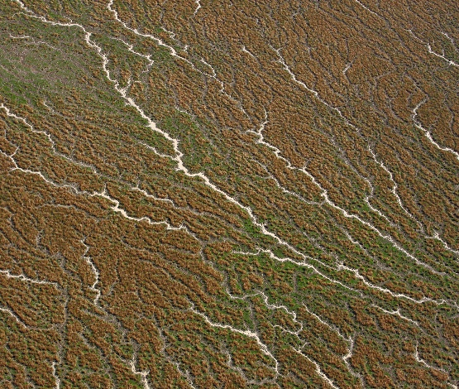

### Introduction

The Marree Innamincka district lies in the far northeast corner of South Australia.

**Landscape Features**

The district is comprised of 3 major bioregions:

* Channel Country
* Simpson-Strzelecki Dune fields
* Gibber or Stony Plains

Both bioregions share similar climates, being very hot arid regions; having hot summers and short typically dry winters. Average temperature ranges between 8-41 degrees Celsius. The region is characterised by having highly variable and unpredictable rainfall, but generally summer dominant with a recorded average of 120-175mm per year across the region.

The most important water source for the District is the main aquifer of the Great Artesian Basin (GAB), with the region covering a major component of the Lake Eyre and Great Artesian Basins. Unique for being the largest internal draining water system in Australia and one of the largest and last remaining unmodified water systems in the world.

Groundwater is discharged from the GAB by mound springs, bores and diffuse upward leakage through the Bulldog Shale. Cooper Basin petroleum wells and the Roxby Downs Township also rely on GAB water.

Gibber or Stony plains are usually made up of gypcrete with entrenched drainage, low escarpments and tablelands. Dunes, occasional lakes and floodplains can be found throughout the stony ranges and tablelands, with the vulnerable gibber layer playing an essential role in soil and vegetation stabilisation.

The channel country features extensive drainage systems, braided channels, vast flood plains and terminal lakes, with highly variable flow patterns, inundation frequency, and salinity and vegetation communities.

Simpson-Strzelecki Dune fields feature a complex of relatively high, parallel sand dunes, interspersed with salt lakes, salt pans and plains. This system responds prolifically to rain, which collect in highly productive swale swamps and is a key factor in determining which plants and animals are present.

The district is unique for the size and diversity of unmodified natural vegetation systems that provide habitat for a number of specialised native flora and fauna species. Native local flora provides the main feed source for pastoral livestock, with many native flora and fauna populations fluctuating between boom and bust cycles.

**Size:** 203,174km2 (39% of the SAAL region)

**Towns (population):** 213 (according to the 2016 census)

Innamincka – 44

Marree – 101

Lyndhurst – 24

Moomba - no permanent residents (fly-in, fly-out only)

**Aboriginal Nations:** Wangkangurru / Yarluyandi (northern), Yandruwandha / Yawarrawarrka (northeast), Arabana (south-west), Dieri (east), Adnyamathanha (south)

**Land use:** Aboriginal land, pastoralism (predominantly organic certified cattle), mining, tourism, conservation (public and private lands), energy exploration, service centres, towns, recreation

**Catchment and key waterways:** Lake Eyre Basin (LEB). Cooper, Kallakoopah, Strzelecki and Warburton Creeks, Georgina and Diamantina Rivers

**National Parks and Reserves:** Innamincka Regional Reserve, Malkumba-Coongie Lakes National Park, Strzelecki Regional Reserve Munga-Thirri Simpson Desert National Park; Kati Thanda-Lake Eyre National Park; Lake Torrens National Park; Elliot Price Conservation Park –Arabana Parks Advisory Committee

**Key stakeholders:**

* Traditional owners
* Pastoral land managers and community
* Petroleum & gas (SANTOS, Beach Energy, BHP) and other mining sector industries
* Township communities and service providers
* Outback Communities Authority (OCA)
* Tourism companies that travel through the region
* Transport and logistic industries

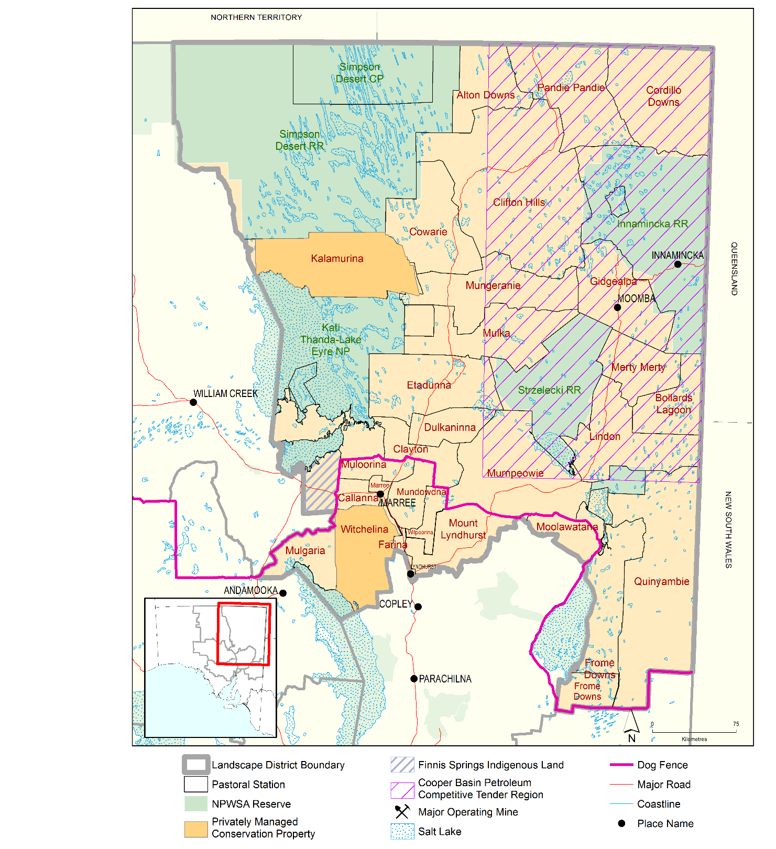

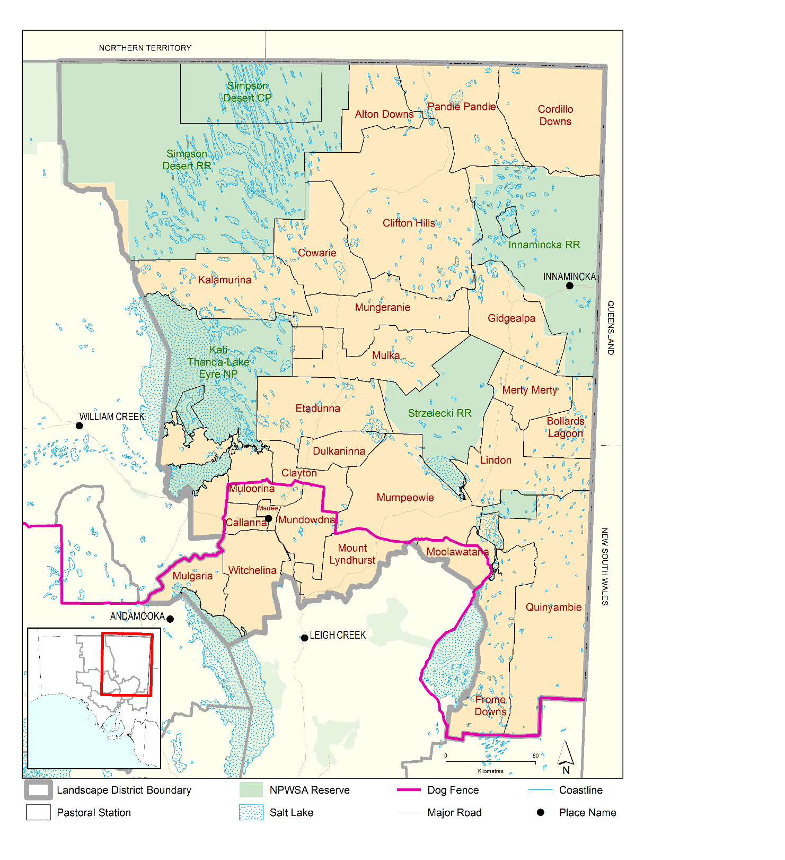

Figure 1: Map of the Marree-Innamincka SAAL Landscape Board’s District

### Role of the Board

Under the Landscape South Australia (LSA) Act 2019, the Board’s role is to undertake, promote and integrate the management of natural resources. Particular reference is given to land management, water resource management and pest animal and plant control. The Board operates as the relevant authority for a range of water, land protection and animal and plant control activities and works with the community in delivering its responsibilities under the LSA Act. Its roles include education and awareness raising aimed at practice change and adoption, encouraging and supporting legislative compliance, and enforcement when needed.

### Role of the Maree-Innamincka Landscape Group

Landscape Groups are an important conduit for community input to landscape planning and design of the Board’s programs. Groups work with local communities, to support the implementation of the Regional Landscape Plan and increase community awareness of Board programs within a Group’s area.

### Landscape Planning Framework

### How this plan was developed

This plan was developed through a series of planning sessions with the Marree-Innamincka Landscape Group in 2021. Information was drawn from past planning documents, current projects and stakeholder knowledge.

### Monitoring and Evaluation

This district plan will be reviewed each year with the Marree-Innamincka Landscape Group to evaluate progress against priorities and plan for the next year of activities.

### Leading the way to biodiverse and productive landscapes in a changing climate

**VISION**

### SA Arid Lands regional priorities

#### Priorities Focus areas

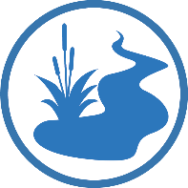

|  |  |  |
| --- | --- | --- |
|  | **CLIMATE RESILIENT REGION**  *Resilient* *landscapes, communities and enterprises are mitigating and adapting to climate change* | **C1** Ensuring climate risk is embedded in all Board business  **C2** Providing land managers with the knowledge and skills they need to mitigate and adapt to climate change  **C3** Exploring adaptation pathways to ensure communities are climate resilient |
|  | **WATER MANAGEMENT**  *The region’s water resources are managed judiciously* | **W1** Planning, research & leveraging infrastructure investment to support the judicious use of groundwater  **W2** Maintaining hydrogeology to protect Great Artesian Basin springs and groundwater-dependent ecosystems  **W3** Understanding and managing surface water systems including the Lake Eyre Basin |
|  | **SUSTAINABLE LAND MANAGEMENT**  *Land management practices protect soil, vegetation and biodiversity* | **L1** Effective pest plant and animal control protecting production systems  **L2** Addressing the threat of excessive total grazing pressure  **L3** Building land managers’ capacity in adaptive agriculture, best practice land management and rehabilitation |
|  | **PROTECTING AND ENHANCING BIODIVERSITY**  *Intrinsic biodiversity values are protected and enhanced* | **B1** Managing key threats to protect natural values  **B2** Taking action for threatened species and ecosystem recovery  **B3** Maintaining and improving the condition of Great Artesian Basin springs and water-dependent ecosystems |
| **C:\Users\askinner\AppData\Local\Microsoft\Windows\INetCache\Content.Word\SAAL People_C.png** | **PEOPLE AND PARTNERSHIPS**  *People and community are central to looking after our landscapes.* | **P1** First Nations partnerships supporting cross-cultural knowledge sharing and landscape management outcomes  **P2** Supporting Landscape Groups to lead community action and education  **P3** Raising awareness of the region’s natural values and connecting people to nature  **P4**  Supporting community action to achieve land, water and coastal management outcomes |

### Marree-Innamincka District Landscape Management Priorities

|  |  |  |  |
| --- | --- | --- | --- |
| Priorities\* | Landscape impacts | District Ranking^ | **Alignment to Regional Priorities\*\*** |
| **Water Management** | Over extraction or diversion of ground and surface water requires management of water affecting activities and accountability for different users. Draw down of water table | High | C:\Users\askinner\AppData\Local\Microsoft\Windows\INetCache\Content.Word\SAAL Water_C.png |
| **Tourism** | Increasing numbers of tourists visiting and not following appropriate behaviour regarding rubbish pollution, illegal firewood collection, trespassing and impact on cultural sites. Resulting in declining biodiversity and a fragmented/degraded landscapes | High |  |
| **Feral Animals** | Feral animals including cats, camels, pigs, rabbits, goats, exotic fish and invertebrates, cane toads and feral cattle. Competing with native animals and livestock for habitat and resources. Negative impact on threatened and unique species from predation on native animals as well as potentially acting as vectors for infectious diseases. | High |  |
| **Road Maintenance** | Inappropriate road design and lack of road maintenance can lead to undesirable water movement in surrounding areas leading to erosion/landscape dehydration. Off road damage where vehicles don’t stay on main tracks, decrease in business and community productivity when transport routes are disrupted. | High |  |
| **Weeds** | Non-native weeds displace native vegetation with flow-on effects for native fauna and impact on stock management and pastoral production. | Med |  |
| **Climate Change** | Decrease in productivity and adapting to unknown changes in pasture type and growth patterns. Due to changing climate with unpredictable and variable rainfall and temperatures. | Med |  |
| **Wild Dog Management** | Wild dog impacts on the pastoral industry particularly along the dog fence where control is required. Stock losses. Understanding and implementing suitable control alternatives for organic businesses. | Low |  |
| **Land Degradation** | Levels of total grazing pressure including livestock, overabundant native herbivores and introduced herbivores leading to loss of biodiversity and ground cover, leading to increased erosion and degrading ecosystem resilience. N.B. *Group decided this was being done well in the region, therefore it wasn’t as high a priority.* | Low |  |
| **Mining and Exploration** | Impacts of mining on biodiversity through habitat clearance, pollution, water extraction, if industry does not follow regulations and restoration requirements. | Low |  |

*^Priority ranking considers the* **magnitude** *of the threat or opportunity (how* **severe/influential** *and how* **widespread/ relevant***) it is, as well as the* **reversibility** *of its impacts\*\** Some district priorities may not be regional priorities for the Board.

### Marree - Innamincka District - Current programs and opportunities (this will regularly be reviewed, change and be updated)

| **District Priority** | **District Ranking** | **Current programs and opportunities** | **Status** | **Who** | **Regional**  **Focus Area** |
| --- | --- | --- | --- | --- | --- |
| C:\Users\askinner\AppData\Local\Microsoft\Windows\INetCache\Content.Word\SAAL Climate_C.png**Climate Resilient Region** | | | | |  |
| Climate change impacts | Med | Carbon Information/Farming Workshops | Ongoing | SAAL LB | C2 |
| Agricultural resilience/climate smart Workshops | Ongoing | SAAL | C2 |
| Carbon Neutral Business Support |  | SAAL LB, PIRSA, MLA | C2 |
| Recording Changes in the Landscape - Weather stations  -PixStix photo monitoring? | Current/Ongoing  Potential | Landholders, SAAL LB | C2 |
| *Community Impact Program* – Foundation of Rural Regional Renewal | Current/Ongoing | SAAL LB | C2/C3 |
| C:\Users\askinner\AppData\Local\Microsoft\Windows\INetCache\Content.Word\SAAL Water_C.png**Water Management** | | | | |  |
| Over extraction of ground water resources | High | Water Management Program, water accounting trials and continued evaluation of WAP | Current/Ongoing | SAAL LB, DEW | W1, W2, W3 |
| Springs | High | Lake Eyre Basin Riparian Springs Project | Current/Ongoing | SAAL | W2, B2, B3, P1 |
| High | Springs monitoring of fenced and unfenced springs | Ongoing | SAAL, FOMS, Arabana Rangers | W2 |
| **C:\Users\askinner\AppData\Local\Microsoft\Windows\INetCache\Content.Word\SAAL Land_C.pngSustainable Land Management** | | | | |  |
|  |  | Deliver Education Activities | Ongoing | SAAL LB, landholders | L1 |
| Support & link Volunteers to Weed Control Activities | Potential | SAAL LB and landholders | L1 |
| Wild dog management | Low | Biteback Program | Ongoing | SAAL LB, landholders | L1 |
| Control Alternatives for Organic Businesses | Potential | SAAL LB, landholders, PIRSA, Organic Accreditation bodies | L1 |
| C:\Users\askinner\AppData\Local\Microsoft\Windows\INetCache\Content.Word\SAAL Biodiversity_C.png**Protecting and Enhancing Biodiversity** | | | | |  |
| Feral animals - cats, camels, pigs, rabbits, goats, exotic fish and invertebrates, cane toads and feral cattle | High | Wetland Wonders Project | Current/2024-2028 | SAAL LB, NPWS | B1, B2 |
| Pest Fish Species in Springs | Ongoing | SAAL, FOMS, PIRSA | B1, B2 |
| Feral Cats Around Townships  Marree & Innamincka | Ongoing | SAAL, OCA, Uni SA, NPWS | B1, B2 |
| Feral Pigs Impacts on Springs | Ongoing | SAAL, Landholders, FOMS | B1, B2 |
| Across Border Partnerships – pest plants and animals | Ongoing | SAAL LB, interstate NRM boards and biosecurity | B1 |
| C:\Users\askinner\AppData\Local\Microsoft\Windows\INetCache\Content.Word\SAAL People_C.png**People and Partnerships** | | | | |  |
| Tourism impacts – rubbish, firewood collection and trespassing cultural sites | High | Improve Awareness and Surveillance of Tourism Impacts  *Greater Tracks App promotion* | Started-due by end of 2024 | SAAL LB, OCA, SA Tourism | P3 |
|  | Support and provide feedback on the Aussie Travel Code | Ongoing | OCA, SAAL LB, FROSAT, RDA | P3 |
| Road design and maintenance | High | Communication and Education Program | Ongoing | SAAL LB, DIT, DEW, SANTOS, OCA? FROSAT? | P3 |
| Mining and exploration | Low | Open Communication and Education Water Affecting Activities Referrals for mining and exploration activities | Ongoing | SAAL LB | P3 |

### Marree – Innamincka Landscape Group actions

Marree-Innamincka Actions list 2024

| **District Priority** | **Opportunity** | **Actions** | **When** | **Collaborate** | **Status** |
| --- | --- | --- | --- | --- | --- |
| C:\Users\askinner\AppData\Local\Microsoft\Windows\INetCache\Content.Word\SAAL Climate_C.png**Climate Resilient Region** | | | | |  |
| Climate change impacts | *Carbon Farming* | SAAL workshops in the region 2025 | TBC | TBC | Not started |
| *Recording Changes in the Landscape* | To be decided by the group at a later date | TBC | Universities, CSIRO, SAAL LB | Not started |
| C:\Users\askinner\AppData\Local\Microsoft\Windows\INetCache\Content.Word\SAAL Water_C.png**Water Management** | | | | | |
| Over extraction of ground water resources | *Water Management Program and WAP* | Support SAAL water team with water affecting activities in the region. |  | SAAL, Landholders | Ongoing |
| Springs | *Springs Monitoring* | Support Photo monitoring and Camera traps to detect feral species and Springs health. | Mid-late 2024? | SAAL, Landholders, FOMS, Arabana, Dieri | Ongoing |
| C:\Users\askinner\AppData\Local\Microsoft\Windows\INetCache\Content.Word\SAAL Land_C.png**Sustainable Land Management** | | | | |  |
| Wild dog management | *Control Alternatives for Organic Businesses* | Engage with industry to support applications for grants to conduct trials | Ongoing | Bite back, PIRSA, Organic Accreditation Bodies |  |
| Land degradation | *Sustainable Grazing Practices - Education* | 1. Group Speaker workshops in district to educate landholders on sustainable grazing techniques – use peer to peer learning 2. Opportunities to utilize locals for road maintenance |  | SAF  MLA, CLO, DIT |  |
| C:\Users\askinner\AppData\Local\Microsoft\Windows\INetCache\Content.Word\SAAL Biodiversity_C.png**Protecting and Enhancing Biodiversity** | | | | |  |
| Feral animals - cats, camels, pigs, rabbits, goats, exotic fish and invertebrates, cane toads and feral cattle | *Wetland Wonders Project – Feral animal control* | 1. Continue discussions with SAAL science team on how community and traditional owners can be further involved in planning, carrying out and receiving results of works. 2. Support landholders to report and monitor feral species numbers 3. Support OCA & NPWS with Feral Cat management around Townships 4. Support landholders, FOMS, PIRSA with pest Fish Species in Springs 5. Support the VET Trial for cats 6. Support Pig Baiting trials in the region 7. Support Rabbit control efforts 8. Support Buffel control and other district weed priorities. | ongoing | DEW, SARDI, Landholders, MI Group, SAAL science team | Ongoing   1. Ongoing. 2 x Feral Cat trapping events held at Marree with 46 Feral cats removed. Future support for NPWS to action at Innamincka by end Nov 2024. |
| C:\Users\askinner\AppData\Local\Microsoft\Windows\INetCache\Content.Word\SAAL People_C.png**People and Partnerships** | | | | |  |
| Tourism impacts – rubbish, firewood collection and trespassing cultural sites | *Improve Awareness and Surveillance of Tourism Impacts* | 1. Tourism app promotion through social media, website and caravan and camping show 2. Acquire Biosecurity signs from livestock SA and distribute/make available to district properties | Ongoing | Other LGs  OCA, RDA, SA Tourism, FRO | 1. Tourism Posters and soft launch actioned by end September 2024. Hard launch by end of 2024. 2. Waiting on signs to distribute during landholder visits by Mid 2025 |
| Road design and maintenance | *Communication and Education Program* | 1. Have Guest speaker from DIT at Meeting annually 2. Update on Strzelecki infrastructure including toilets   Information on Road closures.   1. Group to contact OCA and investigate new Technology to deploy to monitor | Ongoing | SAAL LB, DEW, DIT | 1. Juanita Chester   Manager Regional North & Outback  Road Maintenance attended after meeting #83 to provide update.   1. Interactive map of grading schedule acquired: <https://www.dit.sa.gov.au/infrastructure/road_projects/statewide-road-improvement-and-renewal-works/outback-unsealed-roads-grading-program> |
| Mining and exploration | *Open Communication and Education* | Invite mining representatives to provide updates when appropriate at group meetings and request correspondence from the SAAL Board | Ongoing | SAAL LB, SANTOS, BHP |  |
| Community Wellbeing | *Community Wellbeing and Connection* | 1. Support FRRR Family Fun day at Aroona in September. 2. Support educational programs for SOTA and Marree School |  | SANTOS, PIRSA, MI Group | 1. Actioned 27th September 2024 |

**SAAL LB** SA Arid Lands Landscape Board, **DEW** Department for Environment and Water, **PACC** Port Augusta City Council, **NWTAC** Nukunu Wapma Thura Aboriginal Corporation, **PIRSA** Department of Primary Industries and Regions, **PAQ LG** Port Augusta – Quorn Landscape Group, **FRC** The Flinders Ranges Council, **TPAG** Threatened Plant Action Group, **NPWS** National Parks and Wildlife Service South Australia (DEW).

**PIRSA  
DIT**

**Achievements**

* Greater Tracks App Soft Launch 2024
* Cat management Marree May and Aug 2024
* FRRR family fun day Aroona dam Sep 2024
* Supported Kid on Country and other school events with Radio tracking science equipment for environmental career pathways etc



**Prepared by the SA Arid Lands Landscape Board and Marree-Innamincka Landscape Group  
April 2022. Reviewed 2024**

**T: 08 8648 5307   
E: saal.landscapeboard@sa.gov.au**

**SA Arid Lands Landscape Board**

[**www.landscape.sa.gov.au**](http://www.landscape.sa.gov.au)

