Growing Native Gardens
Port Augusta – Quorn

Growing Native Gardens is an initiative of the SA Arid Lands Landscape (SAAL) Board’s Port Augusta – Quorn Landscape Group that will provide native plants to assist schools and community groups establish native gardens.
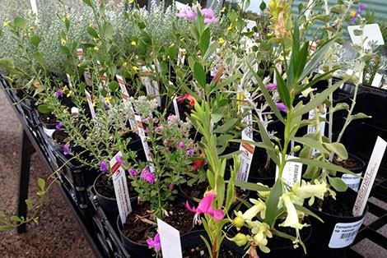

1. What is the ‘Growing Native Gardens’ project?
Planting of trees and shrubs can encourage butterflies and provide habitat for wildlife once established. A budget has been allocated to this project, to provide support for small, short-term projects ranging up to $300 (GST inc.). This project is funded through the SAAL Landscape Board’s Port Augusta – Quorn Landscape Group. Plants need to be purchased and planted by 31 May 2023 and a completion report submitted by 30 June 2023.

2. When are the ‘Growing Native Gardens’ funds available?
The ‘Growing Native Gardens’ project will be delivered in 2022-23 with purchases needing to be finalised and planted by 31 May 2023. Applications will be assessed and notification of success given within two weeks of submitting an application. There is a fixed amount of funding allocated for this project.

3. Who can apply?
Applicants need to be a community group, kindergarten, pre-school, primary or secondary school within the Port Augusta – Quorn Landscape District www.landscape.sa.gov.au/saal. The applicant needs to ensure they have written landholder permission to plant, and can plant on-site at school or at a community location.

4. What can be provided?
Purchasing of local native plants is provided through the project. Large equipment, wages, contractors, designs, and planting consumables are not eligible. Funding could cover purchase of native plants for school grounds planted by students, or purchase and planting of native plants by community groups.

5. How to apply?
Applicants fill in the form that is available on the SAAL website, and from the Community Landscape Officer. For further information or to discuss your project, please contact Brett Devitt, Community Landscape Officer Port Augusta – Quorn Brett.Devitt@sa.gov.au 0409 753 495.

6. What happens once an application is submitted?
Applications are assessed against criteria set by SAAL. Applicants will be contacted for any clarification needed and notified of the outcome of their application within two weeks of submitting the application.

7. What requirements will I have?
Applicants will be responsible for selecting plants, coordinating a school/community planting event/day and establishing a suitable watering and maintenance regime. A short, end of project report will need to be submitted, detailing the works undertaken, with photos taken of the planting activity provided to SAAL.

‘Growing Native Gardens’ Application Form
Contact information
School/Community Group Name:
Contact: First name Last name
Phone number Email address

Plant budget
Please outline the number of plants you require and the cost (up to $300 GST inc.)
Number of plants | Cost $ | Supplier *
 | $ | Australian Arid Lands Botanic Gardens  Port Augusta www.aalbg.org/shop
 | $ | Nuthin’ But Natives  Booleroo Centre www.nuthinbutnatives.com
* Plants can only be purchased from the two suppliers listed

Project details
Project title
Project location
Location name
Location street address
If you are not the property holder, you must ensure you have permission for the activity before submitting this form.
Anticipated planting day ___/___/_____

Project description - Briefly outline the area to be planted and the reasons this project is required

Watering, weeds/pests and maintenance plan – outline who is responsible for caring for plants and plans to water and maintain them over the next 12 months while they establish.

Planting day event
Outline what you intend the planting day to look like and how you plan to involve students and/or community members

Declaration and consent
This section must be completed by an appropriately authorised person on behalf of the applicant organisation (may be different to the contact person listed earlier in this application form).
Signature
First name Last name
Position held in organisation
Date
Internal Use Only
Selection Criteria
☐ Application within Port Augusta – Quorn District. District boundary: www.landscape.sa.gov.au/saal
☐ Application received from a pre-school/kindergarten/school/community group
☐ Application document correctly filled in
☐ Application within range of amount ($300 GST inc.)
☐ Project budget and description within project

Completion Report
‘Growing Native Gardens’
Project details
Project title
Project location
Location name
Location street address

Actual planting day(s) ___/___/_____
Number of students involved _____
Number of First Nations students involved _____
Number of community members/parents involved _____
Photos taken at event attached ☐ Yes

Feedback and learnings – Please provide any feedback of the process and planning for this project

Declaration
Signature
First name Last name
Position held in organisation
Date

