Port Augusta - Quorn
Landscape Group Newsletter
April 2023
The Port Augusta-Quorn Landscape group is one of seven district-based Landscape Groups in the SA Arid Lands region that provide an important link between local communities and the SA Arid Lands Landscape Board. Group members are local people who provide community input into the development and delivery of the board’s five-year plan for the region and help people in their community care for the environment and use natural resources sustainably by building awareness, skills and networks.

Landscape Group meeting updates
The Port Augusta-Quorn Landscape Group met in Quorn on 17 February 2023 for a joint meeting with the Gawler Ranges Landscape Group. Group members were able to exchange ideas and talk about successful workshops, events and projects they could work on in the future. The next meeting is on Tuesday 4 April in Port Augusta, with the following group meeting in Quorn on Tuesday 30 May.
At the joint group meeting held in Quorn were, from left, Melissa Clifton, Lesley Koch, Brenton French, Kate Greenfield, Renata Hackett, Kurt Tschirner, Scott Michael, Amanda Michael holding Phoebe.
Applications are open to join your local Landscape Group and members of the community with an interest in landscape management are encouraged to apply. Their interest may stem from a First Nations, mining, pastoral, business, tourism, pest plant and animal control, conservation of community perspective. If this sounds like you, there are a small number of vacancies that exist in the Port Augusta-Quorn, North Flinders, Gawler Ranges, Marla-Oodnadatta and North East Pastoral groups. Nominations are open until 4pm on 2 May 2023. More information is available on our website at landscape.sa.gov.au/saal.

Growing Native Gardens – Last weeks to apply…
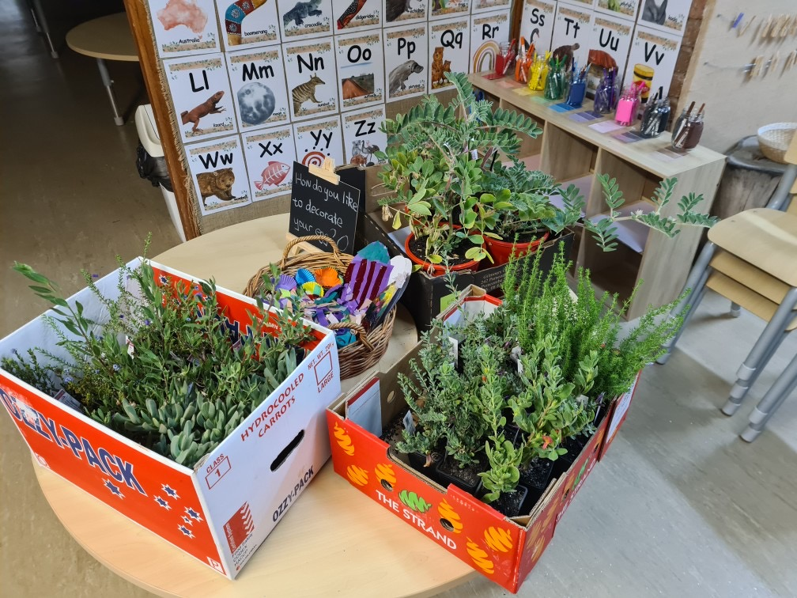The Port Augusta – Quorn Landscape Group has created an opportunity for local schools and community groups in the Port Augusta – Quorn district to receive up to $300 worth of native plants provided to them for planting with students and community group members. Please see our website, contact a group member or contact Community Landscape Officer Brett Devitt for more information. Projects need to be approved and planted by the end of May.

Port Augusta West Childhood Services were able to add these plants to their garden.

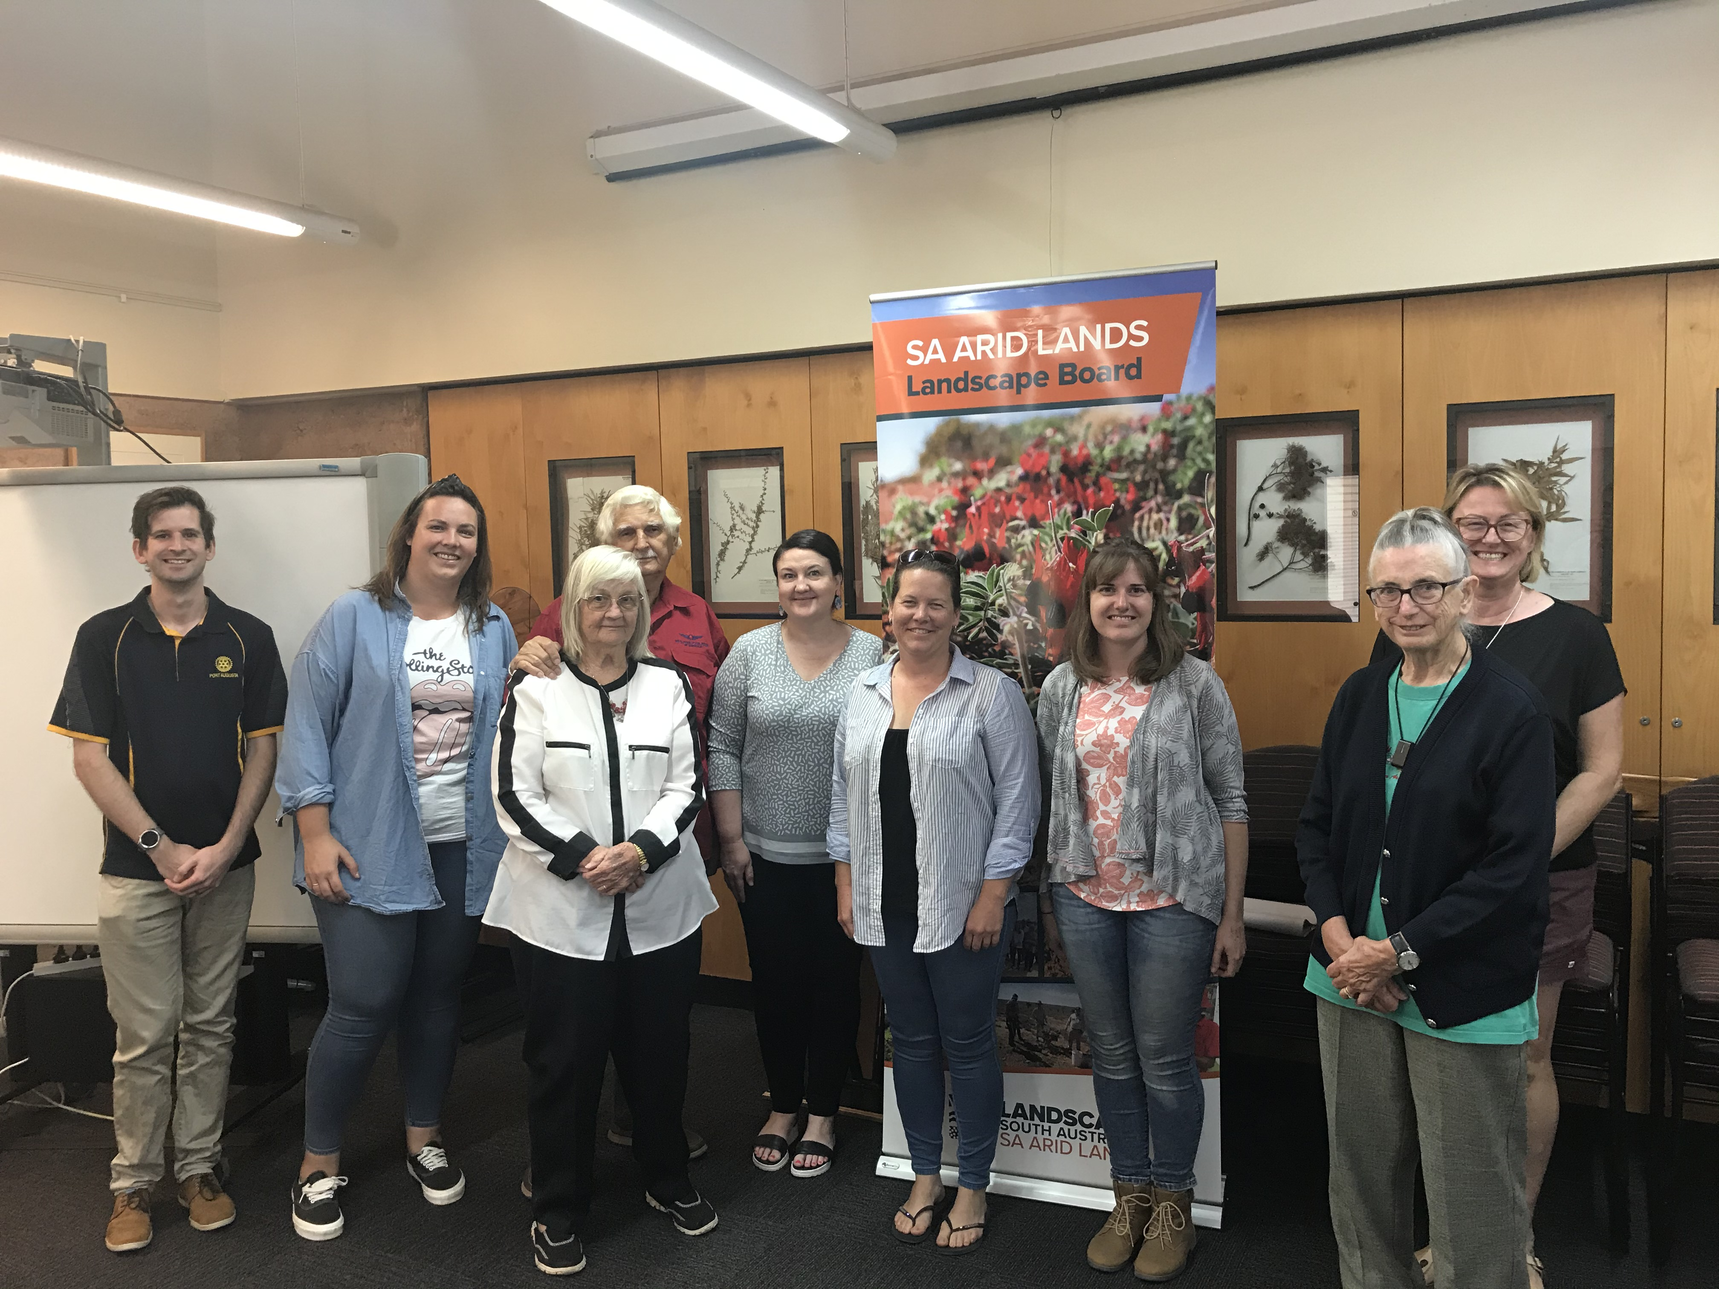Grassroots Grants
If you have a property or community project that addresses environmental outcomes, the SA Arid Lands Landscape Board Grassroots Grants are now open. The program offers grants of up to $10,000 for projects that address one or more of the criteria of: climate resilience; water management; sustainable land management; protecting and enhancing biodiversity and people and partnerships. You can find answers to frequently asked questions and apply on the board’s website at https://www.landscape.sa.gov.au/saal/get-involved/grants-and-funding
Applications close on Monday 8 May 2023.

Port Augusta Garden Club Workshops
A recipiant of a 2022-23 Grassroots Grant, the Port Augusta Garden Club have been busy hosting a series of workshops. There next instalment is an upcoming visit by John Zwar to present on seed colleciton. John Zwar OAM CF has many years experience in our region and understands our arid environment first hand. The Port Augusta Garden Club meet at the clubrooms, corner of Elizabeth Terrace and Paringa Road on the third Wendesday of the month at 2pm. Book your seat by text to Shirley 0439 725 929.

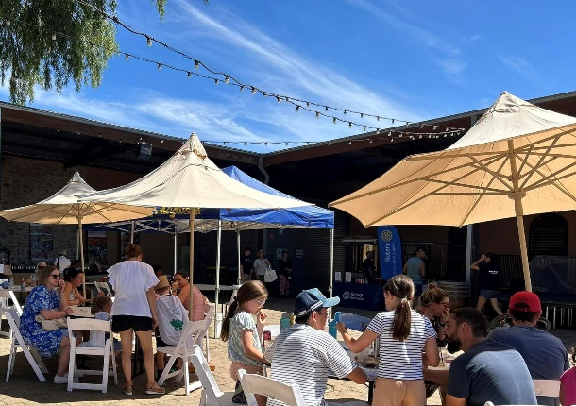
Port Augusta Coastcare Secrets of Port Augusta’s Gulf
Port Augusta Coastcare held its inaugural event, Secrets of Port Augusta’s Gulf at the Old Barracks. More than 250 people came to learn and enjoy the coastal and marine presenations, activities and food.
The family friendly event included childrens activities by Caritas Cubs, entertainment by Dusty Feet Mob and Desert Voices and interactive displays by AusMAP and Marine Discovery Centre. Presentations were provided by Matt Nelson (EPA), Stephan Andrews (Great South Reef), Janine Baker (mangroves), and Jeff Bowey (local marine life in Port Augusta).
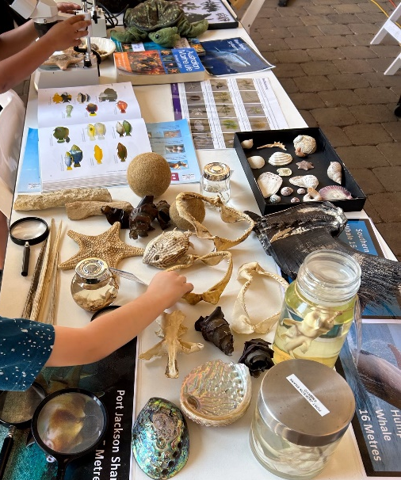
The event aimed to inform the local community on the unique marine and coastal attributes of the region and the group hopes it will encourage more people to connect with the local environment.

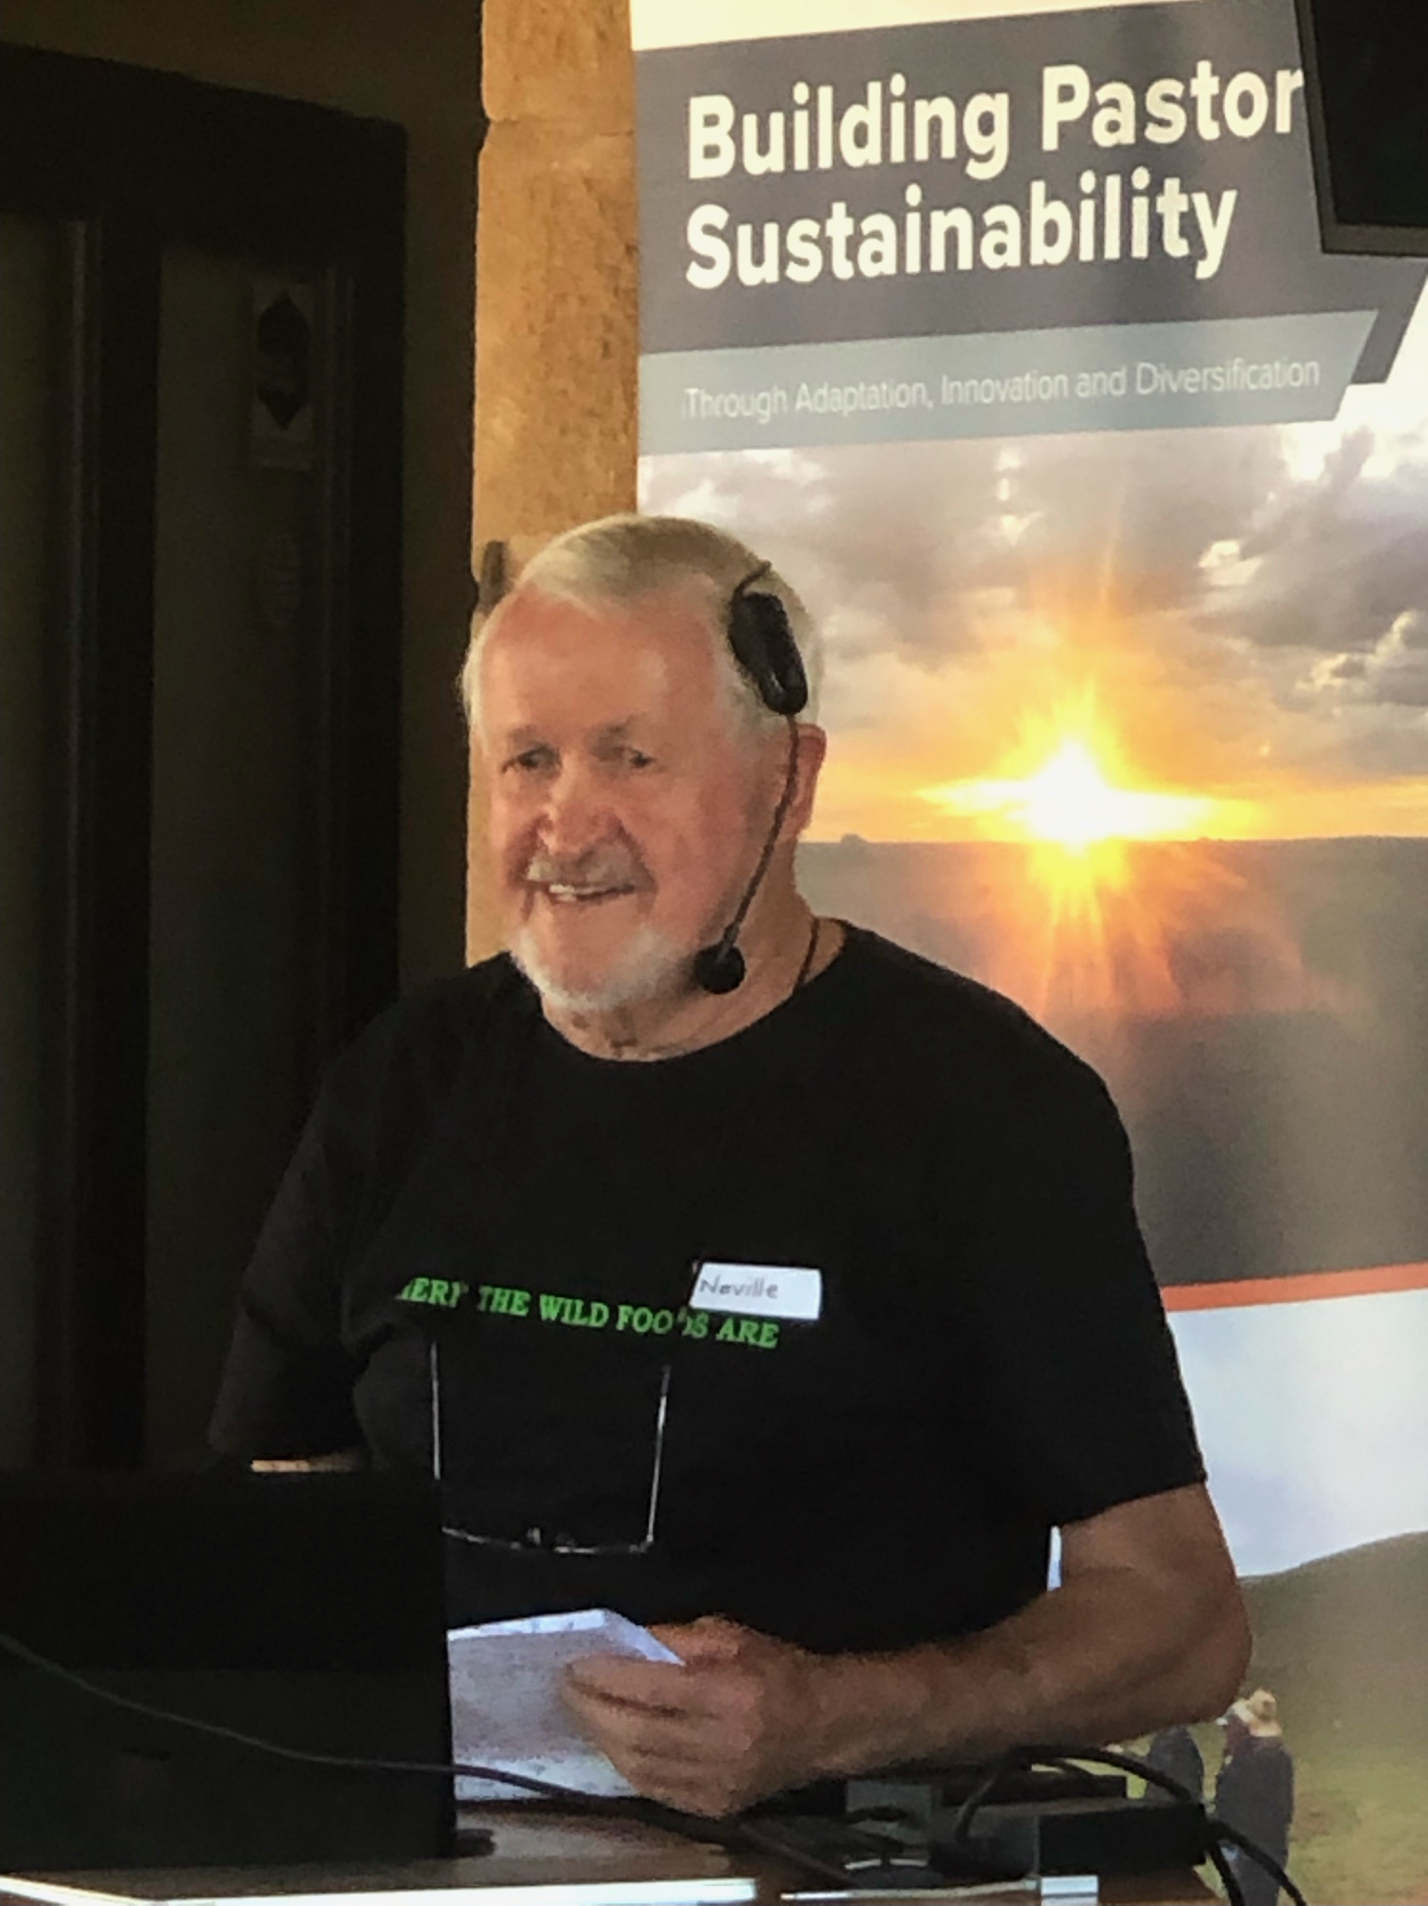Wattleseed Growers Forum in Cradock
A great day looking at native plants of economic importance and the bush foods industry was held at Cradock in February. Guest speakers were Neville Bonney (pictured) and Angus Jones, farmers Trevor Gum and Neil Sleep, as well as Greening Australia’s Mick Durant. Participants enjoyed the field site visit, wattleseed tasting and the event finished with a bushfood themed barbecue at the Cradock Hotel. It is hoped the interest in native plants and bush foods will be continued in Quorn on 21-22 October this year.

DunnART productions show coming in May
SAAL Landscape Board is bringing DunnART productions to the region to perform their Bettongs and Buddies show. Join Rufous the Bettong on his hilarious journey through the bush and meet his animal friends along the way. Aimed at families, you will have the chance to meet the native animals after the show for a hold or pat and to learn more about our amazing wildlife.
Shows will be held in both Port Augusta and Quorn, on the first weekend in term two. The show in Port Augusta will be on Saturday 6 May in the Children’s Explorer Garden at the Australian Arid Lands Botanic Garden at 2pm, and the Quorn show will be on Sunday 7 May at the Town Hall at 11am. Be sure to book your tickets online to guarantee your seat.
Port Augusta Quorn

Port Augusta Quorn Community Landscape Officer
Brett Devitt
Email: Brett.Devitt@sa.gov.au
Phone: 0409 753 495
www.landscape.sa.gov.au/saal

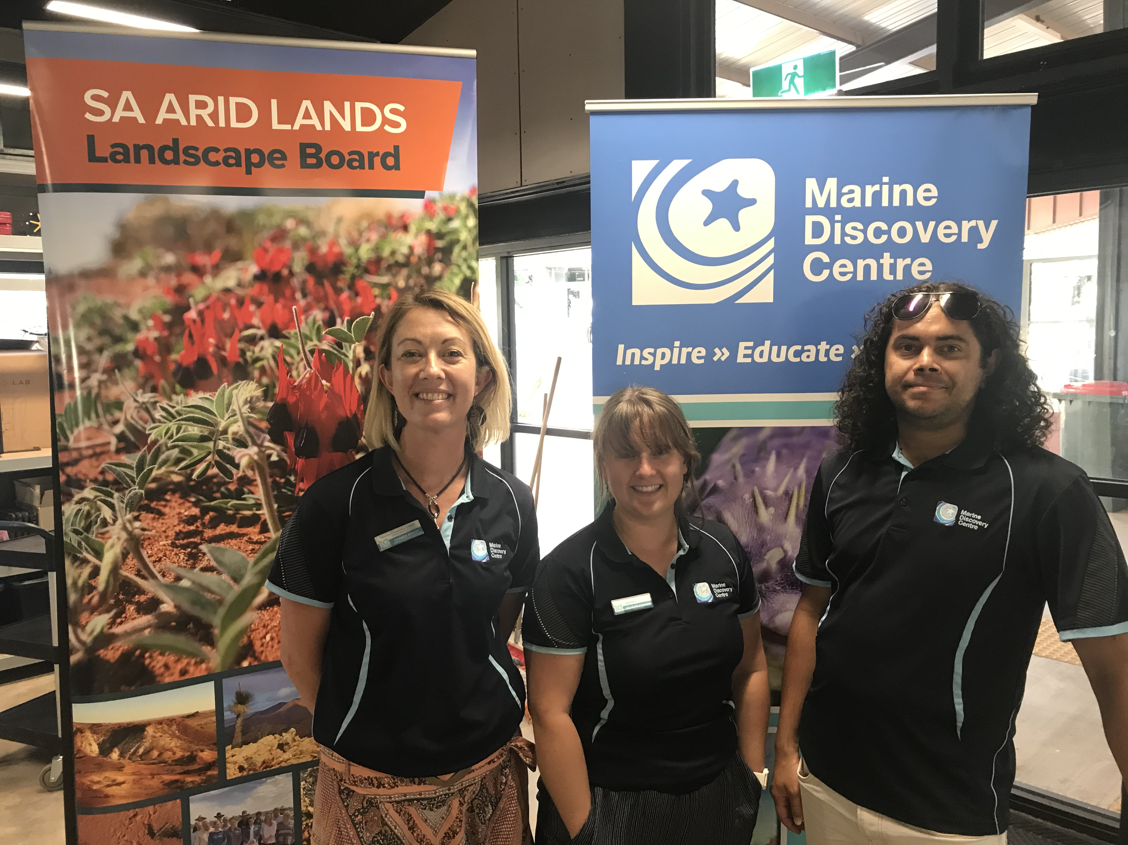Marine Discovery Centre
The Port Augusta – Quorn Landscape Group brought the Marine Discovery Centre from Henley Beach to the area to conduct school incursions and hold a Professional Development session with teachers in March. The Marine Discovery Centre is the only dedicated marine educational facility for schools in SA.
School incursions were offered across the district, with more than 150 students from Willsden Primary School, School of the Air and Port Augusta Secondary School taking part. Marine Discovery Centre is closely aligned with ACARA, particularly the cross-curriculum Sustainability priority. Eleven teachers from Port Augusta and Quorn gathered on Thursday 16 March for a Professional Development session with the Marine Discovery Centre. It was a great opportunity to learn about their objectives, find good tips for resources, and how to support children’s development and learning through Nature Education.

Upcoming Events
Date | Description
Friday – Monday  14-17 April  8.00am | Birds SA – Port Augusta  Bird watching field trip and camp to Hiltaba Nature Reserve. Camp out facilities available, costs apply. Bring binoculars, sturdy footwear, hat, morning tea and lunch Contact Peter 0457 708 859 or Bernie 0419 863 834.
Wednesday  19 April  2.00pm | Port Augusta Garden Club  The third of a series of talks with arid zone amenity horticulturist John Zwar. John will give a talk and demonstration on seed collection. Please register with Shirley by text 0439 725 929.
Saturday 6 May  2pm Port Augusta | Bettongs & Buddies – Port Augusta show  Join Rufous the Bettong on his hilarious journey through the bush and meet his animal friends along the way. More details are in this newsletter, including booking information.
Sunday 7 May
11am Quorn
Wednesday  10 May  5.30pm | Port Augusta Coastcare Meeting  Annual General Meeting. SAAL Landscape Board Office, 1 Jervois St.
Wednesday  17 May  2.00pm | Port Augusta Garden Club  The fourth of a series of talks with arid zone amenity horticulturist John Zwar. John will give a talk on sensory garden of native plants.
Thursday  18 May  All day | Buckleboo Stickybeak Day - The secret life of seed and soils  The Secret Life of Seed and Soils will provide an understanding of rangeland soils and plant adaptations. Tickets will be released through https://www.landscape.sa.gov.au/saal/get-involved/events
Sat – Sunday  20-21 May  8.00am | Birds SA – Port Augusta  Bird watching field trip and camp to Catninga Station. Meeting point is the Stirling North service station at 8am. Please bring binoculars, sturdy footwear, hat, morning tea and lunch. Contact Peter 0457 708 859 or Bernie 0419 863 834.
Saturday  3 June  1.00pm | Friends of the Australian Arid Lands Botanic Gardens  The second friends meeting of the year, in the conference room of the Australian Arid Lands Botanic Garden.
Sunday  18 June  8.00am | Birds SA – Port Augusta  Bird watching field trip and camp to Carriewerloo to Yudnapinna Road. Meeting point is the start of the Stuart Highway. Bring binoculars, sturdy footwear, hat, morning tea and lunch. Contact Peter 0457 708 859 or Bernie 0419 863 834.

Please get in contact if you would like an event added to future newsletters

Acknowledgement of Country: We acknowledge and pay respects to both Barngarla and Nukunu Nations, their elders past, present and emerging, and their strong connection to Country on which the Port Augusta – Quorn district is located.

