Port Augusta - Quorn
Landscape Group Newsletter
January 2023
The Port Augusta-Quorn Landscape group is one of seven district-based Landscape Groups in the SA Arid Lands region that provide an important link between local communities and the SA Arid Lands Landscape Board. Group members are local people who provide community input into the development and delivery of the board’s five-year plan for the region and help people in their community care for the environment and use natural resources sustainably by building awareness, skills and networks.

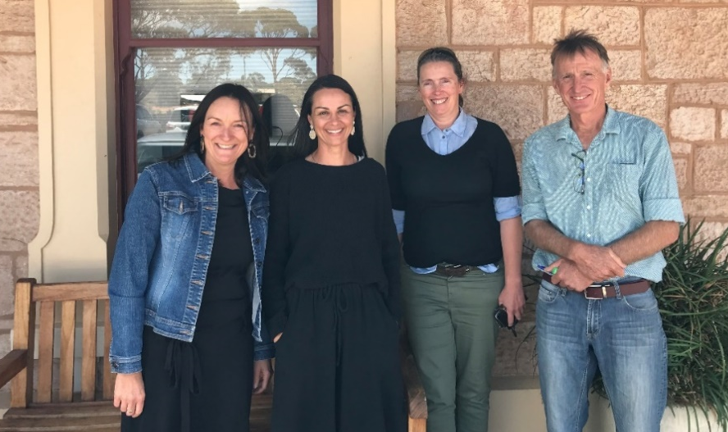
Landscape Group meeting
The Port Augusta-Quorn Landscape Group met in Port Augusta on 3 December 2023 for an informal meeting. The group reviewed its achievements for 2022 and planned activities for 2023. The next group meeting will be jointly held with the Gawler Ranges Landscape Group in Quorn on Friday, 17 February. Please get in touch if you would like to come along.

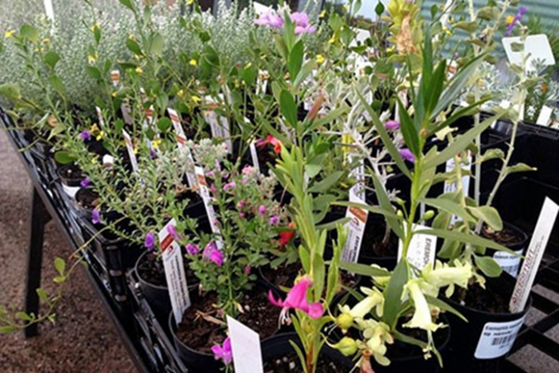
Planting Native Gardens
The Port Augusta – Quorn Landscape Group has created an opportunity for local schools and community groups in the Port Augusta – Quorn district to receive up to $300 worth of native plants for planting with students and community group members. To apply, please see our website, or contact Community Landscape Officer Brett Devitt for more information.
landscape.sa.gov.au/saal/get-involved/grants-and-funding

Grassroots Grants – new round opening soon
Applications for SA Arid Landscape Board's 2023/24 Grassroots Grants program will open from 6 March 2023 until 8 May 2023. Grants of up to $10,000 (GST exclusive) are available to help raise awareness of the region’s natural values and to connect people to nature, and support community action to achieve land, water and coastal management outcomes. Details of successful 2022/23 Grassroots Grants, as well as previous years grants, can be found on our website landscape.sa.gov.au/saal/get-involved/grants-and-funding.

Grants Workshop
Sponsored by the Port Augusta - Quorn Landscape Group, this face-to-face Grant Writing Workshop is aimed at helping community groups and individuals apply for the SA Arid Lands Landscape Board's Grassroots Grants, which will open in early March, as well as other environmental and community grants. The 2.5 hour workshop will be run by Ellenor Day from local communications company Wordsworkers. This is a great chance to network with other like-minded individuals and groups afterwards over lunch. Please book your seat at events.humanitix.com/grant-workshop. Bookings are essential.

Port Augusta Coastcare
Port Augusta Coastcare is preparing for its upcoming family friendly community day The Secrets of Port Augusta’s Gulf on Saturday, 18 March from 12noon to 4pm in the Barracks at Port Augusta.. This event will include stalls by Great Southern Reef, Marine Discovery Centre, AusMAP microplastics, Department for Environment and Water, Fishcare volunteers and more. Guest speakers will include Stefan Andrews, Janine Baker, Matt Nelson and Anita Nedosyko. Food and drinks will be available, as will dedicated children’s activities. The Friends of the Australian Arid Lands Botanic Gardens will showcase and sell AridSmart native plants.
Port Augusta Coastcare plans to use this event to inform the local community on the unique marine and coastal attributes of the region, and is hoping to encourage more people to connect with the local environment. This event is supported by the SA Arid Lands Landscape Board’s Grassroots Grants.

Port Augusta Garden Club Workshops
Port Augusta Garden Club, through support from an SA Arid Lands Landscape Board Grassroots Grant, have been busy hosting a series of community workshops encouraging native planting in home gardens and promoting their benefits for biodiversity. In 2023, the club will offer sessions by horticulturist John Zwar OAM CF. John has many year’s experience in our region and understands our arid environment first hand. John will present Plant Names and Basic Botany on Wednesday 15 February at 7pm. The Port Augusta Garden Club meets at the corner of Elizabeth Terrace and Paringa Road in Port Augusta. Each meeting includes a plant auction and a show bench display with a different theme each month. It is a great chance to meet with like-minded gardeners. Book your seat by text to Shirley on 0439 725 929.

Wattleseed Growers Forum
This event is a stickybeak afternoon for farmers interested in the wattleseed industry and native plants of economic importance. It is suitable for landholders interested in farm diversification and bush food business opportunities. The forum starts at 1pm on Wednesday February 22 and guest speakers include native plant specialists Neville Bonney and Angus Jones, farmers Trevor Gum and Neil Sleep, as well as Greening Australia’s Mick Durant. At the end of the afternoon there will be a bush foods themed BBQ at the Cradock Hotel. Tickets are free. Book now or you might miss out – places are limited. events.humanitix.com/wattleseed.

SA Arid Lands Landscape Board Appointments
Douglas Lillecrapp from Todmorden Station in the Marla Oodnadatta district was recently appointed as the board’s new presiding member and Flinders Ranges Council CEO Eric Brown was appointed to the board. They will attend their first meeting in February.

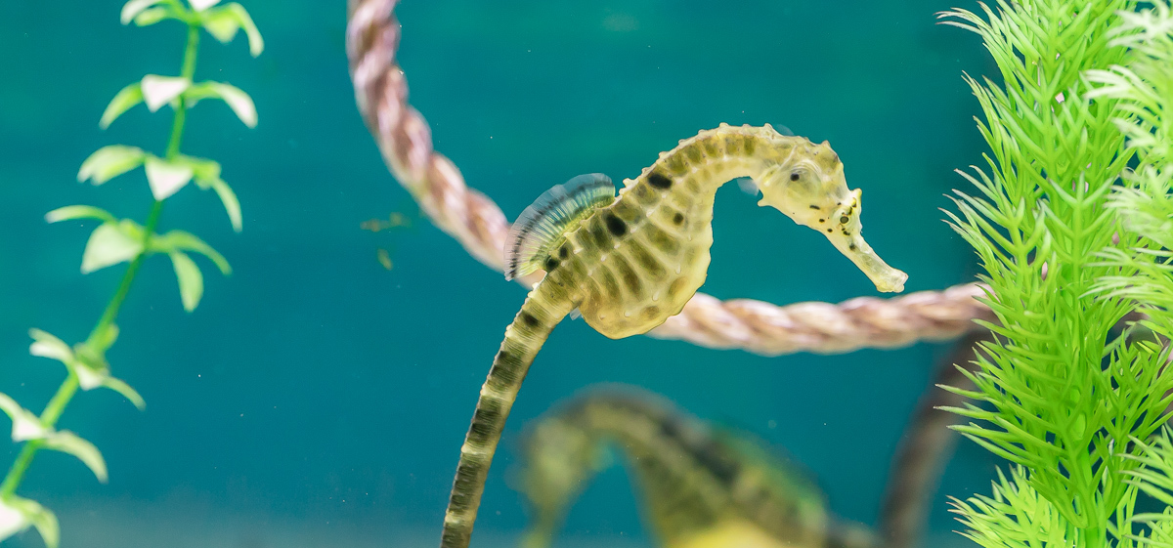
Nature Education 2023

Marine Discovery Centre school incursions
The Port Augusta – Quorn Landscape Group has invited the Marine Discovery Centre to Port Augusta to provide school incursions, bringing an educational and exciting range of activities to classrooms or a local beach. Students will discover the wonders of South Australia's marine and coastal environments and the human impacts that may affect them.
Programs available include Great and Small Marine Creatures, Ocean Warriors-Protecting our Environment, Survival of the Sea, and Curious Classification. Visits can include activities focused on Aboriginal Artefacts and history, Virtual Reality headsets, Discovery Dive in SA waters, Marine Food Chains, Marine Litter, Ocean Currents, Recycled Art, Creature Features, Sustainable Fishing Practices, and Beachcombing.
These learning experiences allow students to discover the wonders of our local marine environment through interactive and hands-on activities linked to Australian Curriculum, Assessment and Reporting Authority (ACARA). Activity sheets, lesson ideas and plans can be used in conjunction with information sheets. Spots for classes are available during Week 7 - Thursday 16 and Friday 17 March. Please get in contact with Brett Devitt for bookings or more information.

Teacher Professional Development
This Marine Discovery Centre workshop in Port Augusta offers examples of learning experiences to support children’s development and learning through Nature Education. The Marine Discovery Centre is closely aligned with ACARA, particularly the cross-curriculum priorities of Sustainability and Aboriginal and Torres Strait Islander Histories and Cultures.
Participants will explore the positives of connecting with nature through learning activities and explore marine learning topics. The Marine Discovery Centre will also showcase resources to support teaching and learning. Focus areas will include: marine environments as part of the cross curriculum priority of sustainability, utilising marine environments for teaching general capabilities, and resources for more information and inspiration
At the conclusion of this workshop, you will have identified a practical pathway to support learning through marine topics. Book a seat for this development workshop at events.humanitix.com/marine-pd.

Port Augusta Quorn Community Landscape Officer
Brett Devitt
Email: Brett.Devitt@sa.gov.au
Phone: 0409 753 495
www.landscape.sa.gov.au/saal

Upcoming Events
Wednesday  1 February  5.30pm - 6.30pm | Port Augusta Coastcare Meeting  SAAL Landscape Board Office, 1 Jervois St.
Sunday  12 February  8.00am | Birds SA – Port Augusta  Bird watching field trip to Whyalla Conservation Park and Point Lowly. Meeting at the Iron Knob turn-off tanks. Please bring binoculars, sturdy footwear, hat, morning tea and lunch Contact Peter 0457 708 859 or Bernie 0419 863 834.
Wednesday  15 February  7.00pm | Port Augusta Garden Club  The start of a series of talks horticulturist John Zwar. John will give a talk on plant names and basic botany. Please register with Shirley by text 0439 725 929.
Wednesday  22 February  1.00pm | Wattleseed Growers Forum - Cradock  A stickybeak day for farmers about the wattleseed industry and regenerative agriculture. Tickets at events.humanitix.com/wattleseed.
Saturday  4 March  1.00pm | Friends of the Australian Arid Lands Botanic Gardens  The first friends meeting of the year. Meeting in the conference room of the Australian Arid Lands Botanic Garden.
Wednesday  15 March  7.00pm | Port Augusta Garden Club  The second of a series of talks with horticulturist John Zwar. John will give a talk on native landscaping in Quorn. Please register with Shirley by text 0439 725 929.
Thursday  16 March  4.30pm – 5.30pm | Teachers Professional Development session with the Marine Discovery Centre  The Marine Discover Centre will explore topics that can be incorporated into marine and learning. Book your free seat at events.humanitix.com/marine-pd.
Saturday  18 March  12pm-4pm | Secrets of Port Augusta’s Gulf – The Barracks, Port Augusta  A family friendly community event looking at the uniqueness of the Upper Spencer Gulf. Stalls and hands on activities, with children’s activities. Food and drink available on site. Hosted by Port Augusta Coastcare Inc, through support from a Grassroots Grant
Sunday  19 March  8.00am | Birds SA – Port Augusta  Bird watching field trip to Telowie and Nelshaby Gorge. Meeting point is Telowie Gorge. Please bring binoculars, sturdy footwear, hat, morning tea and lunch Contact Peter 0457 708 859 or Bernie 0419 863 834.
Sunday  25 March  10.30am | Applying for grants workshop – Australian Arid Lands Botanic Garden  A grant writing workshops for groups and individuals looking to apply for 2023/24 Grassroots Grants. Workshop facilitated by Wordsworkers communications. Book a seat at events.humanitix.com/grant-workshop.
Please get in contact if you would like an event added to future newsletters
Acknowledgement of Country: We acknowledge and pay respects to both Barngarla and Nukunu Nations, their elders past, present and emerging, and their strong connection to Country on which the Port Augusta – Quorn district is located.

