# 2025 Nature Education - Port Augusta – Quorn

*These are opportunities available for schools, teachers, and educators in the Port Augusta Quorn District.*

## Grassroots Grants 2025-2026

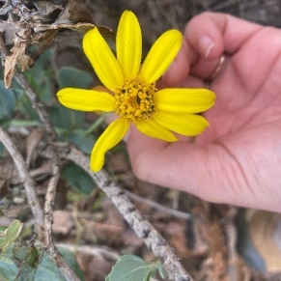Each year the SA Arid Lands Landscape Board Grassroots Grants program aims to support landholders, volunteers, community groups, not-for-profits and First Nations in local projects that care for our soil, water and biodiversity, while addressing the board’s priorities. The grants are offered for a financial year and will open March – May 2025. The Community Landscape Officer can help you with your project development and application process. Previously awarded projects can be found on the board’s website, under [**Get Involved – Grants and Funding.**](https://www.landscape.sa.gov.au/saal/get-involved/grants-and-funding)

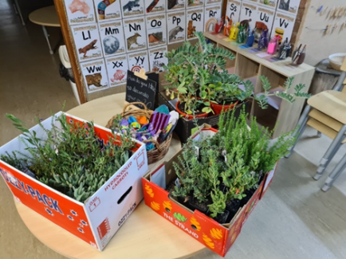**Growing Native Gardens 2025**

Port Augusta-Quorn Landscape Group is excited to continue an opportunity for local schools and community groups in the district to receive up to $300 worth of native plants for planting with students and community group members. Please keep an eye out on our socials and website or contact Community Landscape Officer Brett Devitt to express your interest. Applications will be open until 1 May 2025.

**Marine Discovery Centre visits - School Incursions**

The very popular [**Marine Discovery Centre (MDC)**](https://www.marinediscoverycentre.com.au/)will return to Port Augusta in April 2025 to provide school incursions in the district. MDC staff will teach students about coastal and marine environments. These always book out early, so get in touch with Brett if you would like the MDC to visit your class/school.

To help prepare your class for a visit, or if you miss out, there are many useful and local resources. [**The Rockpool Website**](https://therockpool.org.au/)is SA based, and points you in the right direction to the best resources available to help understand these environments and how to protect them.

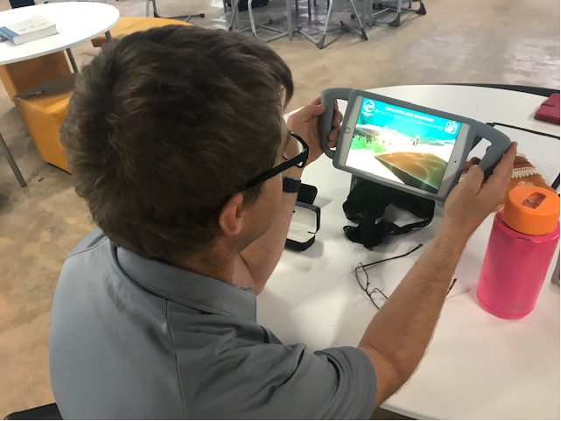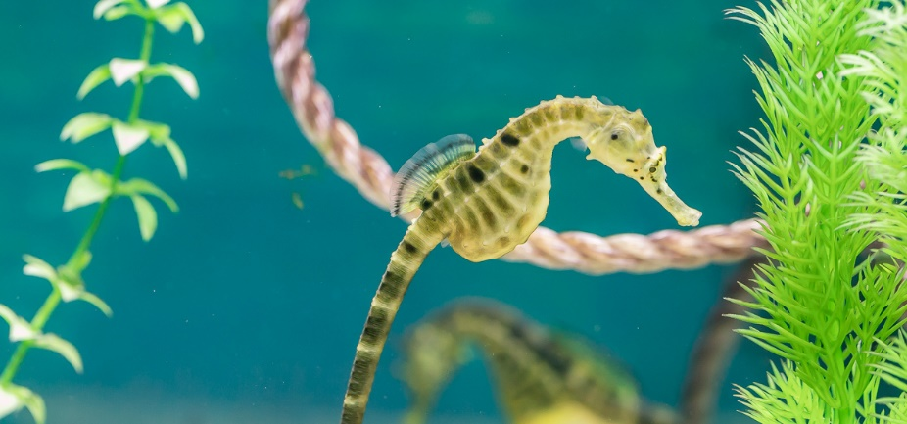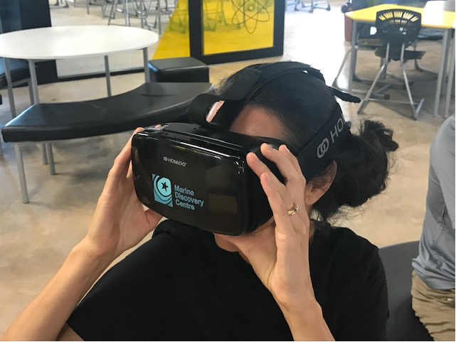

**Acknowledgement of Country:** We acknowledge and pay respects to both Barngarla and Nukunu Nations, their elders past, present and emerging, and their strong connection to Country on which the Port Augusta-Quorn district is located.

## Podcasts and websites

### [**Authors in Conversation – Sustainability through Stories**](https://www.youtube.com/watch?v=llydgAShj9k&list=PLInk2nMrLuvnloZAqJA53-zndo8musZZJ&index=3)

Stories are more than just words. Telling stories is how humans make sense of the world and pass on knowledge from one generation to the next. They educate, evoke emotions, shift attitudes, values, and behaviours, and inspire action for change.

A panel of celebrated Australian children's authors recently joined the Green Adelaide team, discussing how to teach sustainability through the magic of children's literature. Learn how the power of storytelling can inspire curiosity and lead to learning experiences that empower young people to take-action for the future. Featuring authors Jackie French, Phil Cummings, and Nola Turner-Jensen.

[**Access resources**](https://aus01.safelinks.protection.outlook.com/?url=https%3A%2F%2Fdrive.google.com%2Fdrive%2Ffolders%2F17oX9moEiYvHeumvt9cXqwwb0L_YyASqz%3Fusp%3Dsharing&data=05%7C02%7Cbrett.devitt%40sa.gov.au%7Cd7e2b108d9464a52c86008dc9fcc0640%7Cbda528f7fca9432fbc98bd7e90d40906%7C1%7C0%7C638560945852001950%7CUnknown%7CTWFpbGZsb3d8eyJWIjoiMC4wLjAwMDAiLCJQIjoiV2luMzIiLCJBTiI6Ik1haWwiLCJXVCI6Mn0%3D%7C0%7C%7C%7C&sdata=4XooBx6Gs9kUl84cDJtYFPrHXiUxdBLqPNeRP0D2B8o%3D&reserved=0)to support your teaching and learning around our theme including:

* Teacher notes for the books that are discussed
* Articles, guides and useful weblinks

[**Visit the Green Adelaide YouTube channel**](https://aus01.safelinks.protection.outlook.com/?url=https%3A%2F%2Fyoutu.be%2FllydgAShj9k%3Fsi%3Ds99ec9ABdtcCr97g&data=05%7C02%7Cbrett.devitt%40sa.gov.au%7Cd7e2b108d9464a52c86008dc9fcc0640%7Cbda528f7fca9432fbc98bd7e90d40906%7C1%7C0%7C638560945852012074%7CUnknown%7CTWFpbGZsb3d8eyJWIjoiMC4wLjAwMDAiLCJQIjoiV2luMzIiLCJBTiI6Ik1haWwiLCJXVCI6Mn0%3D%7C0%7C%7C%7C&sdata=rdDjKvhIJfrxFeLyuwJIBhNHuJJt9qKRZKymdFXqikQ%3D&reserved=0)to access the recording of the online PD, as well as many other great videos. You can [**visit the SA Arid Lands Landscape Board YouTube channel**](https://www.youtube.com/@saaridlandslandscapeboard3880/videos) to see local content to our region.

## Local Excursion Ideas

### **Pithi Kawi Bush Tucker Garden – Quorn**

This garden, established by Quorn Community Landcare Group volunteers and The Flinders Ranges Council celebrates the Nukunu connection to the area. The garden is divided into bush foods, medicines, and tools and implements. You can see more information on [**The Flinders Ranges Council website.**](https://www.frc.sa.gov.au/tourism/what-to-do/pithi-kawi-bush-food-garden) No formal tours are available, but background information is available from the Community Landscape Officer.

### **Australian Arid Lands Botanic Garden – Port Augusta** *A living museum for the natural world.*Maria Taylor of *Outside the Box Learning* has brought nature-based learning to life with the volunteers from Friends of the Australian Arid Lands Botanic Garden, who completed their new outdoor learning passport. This new resource is excellent for students to use whilst visiting the garden for excursions. These booklets help learn hands-on, practical tips in the sessions, exploring connections with the Early Years Learning Framework and Australian Curriculum priorities. Booklets and cards are available in the gift shop, or through the Friends Group – email [**friends@aalbg.sa.gov.au**](mailto:friends@aalbg.sa.gov.au) You can read more information on the [**Friends of the AALBG website**](https://friendsaalbg.org.au/about/) and on council’s [**Australian Arid Lands Botanic Garden website.**](https://www.aalbg.org/)

   

## Local Groups

A range of community groups in the district that you might be interested in.

**Port Augusta Coastcare**Port Augusta Coastcare meets every six weeks at the Old Court House, Jervois St Port Augusta. [Facebook - Port Augusta Coastcare](http://www.facebook.com/PortAugustaCoastcare/)  Contact Brett on 0409 753 495 or email pacoastcare@gmail.com

**Birds SA – Port Augusta “*The Babblers*”**Bird watching field trips each month. Bring sturdy footwear, hat, sun protection and morning tea/lunch Allow for a full day out. Contact Bernie 0419 863 834 or email b.hasse55@outlook.com

**Port Augusta Garden Club**Meeting on the third Wednesday of the Month, at corner of Elizabeth Terrace and Paringa Road, Willsden. Show bench, interesting guest speakers and plant sales each meeting. [Facebook - Port Augusta Garden Club](https://www.facebook.com/groups/608051573025990/)  Club contact Shirley 0439 725 929.

**Friends of the Australian Arid Lands Botanic Gardens**Meet quarterly in the conference room of the Australian Arid Lands Botanic Garden. Volunteer tour guiding, plant propagation and garden work (Wednesdays). [Website - Friends of the Australian Arid Lands Botanic Garden](https://friendsaalbg.org.au/) Contact Brian 0418 896 995.

**Quorn Community Landcare Group**

Community volunteers who help promote sustainable land management practices in the Quorn District. Usually meeting in the Quorn Bush Foods Garden (Pithi Kawi). [Facebook - Quorn Community Landcare](https://www.facebook.com/QuornLandcare/)  [quorncommunitylandcaregroup@gmail.com](mailto:quorncommunitylandcaregroup@gmail.com)

## Coming Events

**Nature Festival 2025 – October School Holidays**This will be the sixth year for this festival of community based nature events around the state. Keep an eye out on the website [Nature Festival South Australia](https://www.naturefestival.org.au/)

**Science by the Sea – Saturday 12 April**Port Augusta Coastcare will hold a children’s focused *Science by the Sea* event on Saturday 12 April in Port Augusta. In attendance will be the Marine Discovery Centre. For more information, keep an eye out on their [Facebook - Port Augusta Coastcare](http://www.facebook.com/PortAugustaCoastcare/)

**Pastoral Field Day – Thursday 20 March – Port Augusta Racecourse**Hosted by the SA Arid Lands Landscape Board, the Pastoral Field Day will showcase sustainable agricultural practices, technology and drought preparedness. Pastoralists showcasing property trials, trade stalls, on-site demonstrations, entertainment and activities for children. Free entry.

## Andy the Ant is back

The popular children’s publication *Andy the Ant* has been revised and reprinted by the SA Arid Lands Landscape Board. The fun activity book helps school-aged children understand the natural resources of the SA Arid Lands region through stories, games, crosswords, dot-to-dot and find-a-word puzzles.

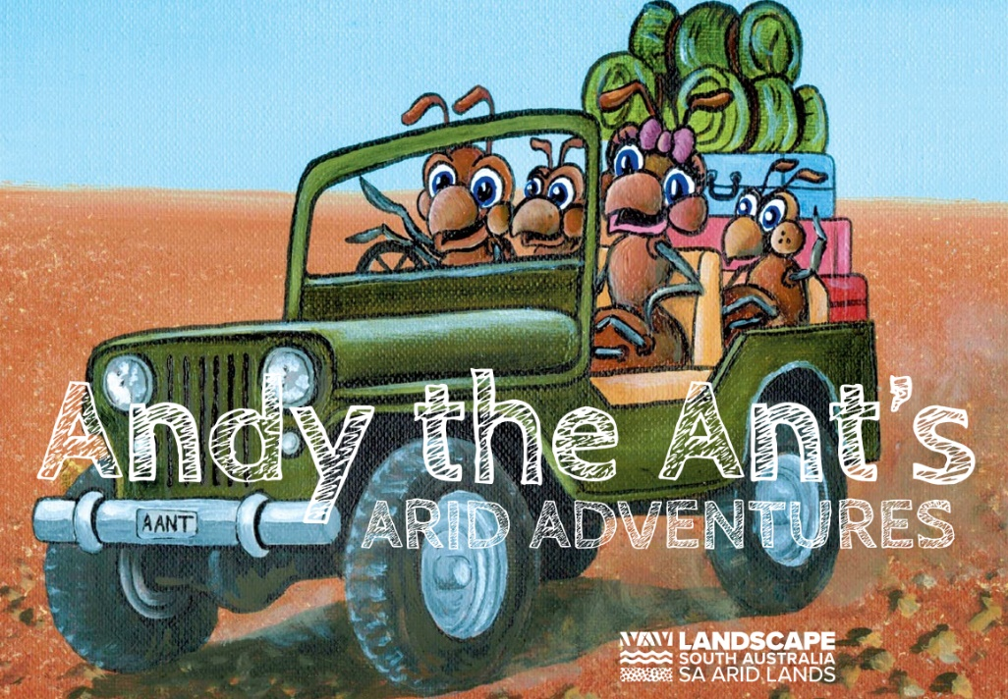Meeting Andy the Ant as he travels around the region are Robby the Rascally Rabbit, Camilla Camel, Barry the Bearded Dragon, Wanda the Wedge-tailed Eagle and Pete and Pam the Pastoralists. They are joined in this latest edition by Fiesty Fred the Feral Cat, Keith the Kowari and Regina and Russell the Rangers.

[**Download your own copy from our website**](https://cdn.environment.sa.gov.au/landscape/images/saal/9324_SAAL_Carkit_Kids_FINAL.pdf) or get a printed version from your Community Landscape Officer. The reprint was supported by the Kingoonya Landscape Group.

## Across the Outback

For more than 25 years, *Across the Outback* has provided updates to the SA Arid Lands community on a range of government activities being undertaken. In 2017 an online version that could be delivered straight to your inbox was introduced. The board produce two hard copy publications alongside two e-bulletins.

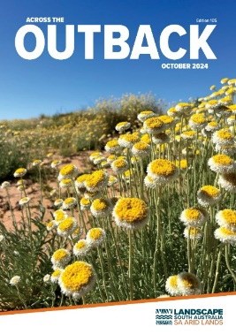The latest print edition of the board’s *Across the Outback* magazine includes updates on the board’s many projects and activities, including an achievements report for 2023-24. You can [**download this edition**](https://createsend.com/t/i-1464AE2E9FDF42DD2540EF23F30FEDED) or past copies to read on our [**website**](https://www.landscape.sa.gov.au/saal/news-resources/publications)or [**subscribe**](https://www.landscape.sa.gov.au/saal/news-resources/publications/subscribe)to receive your own copy directly in your letterbox or inbox, or both.

Regular updates and opportunities are posted on our [Facebook - SA Arid Lands Landscape Board](https://www.facebook.com/SAALLandscapeSA/) or Instagram @saaridlands.

Port Augusta Quorn  
Community Landscape Officer

Brett Devitt   
Email: [Brett.Devitt@sa.gov.au](mailto:Brett.Devitt@sa.gov.au)   
Phone: 0409 753 495

**www.landscape.sa.gov.au/saal**[**Facebook - SA Arid Lands Landscape Board**](https://www.facebook.com/SAALLandscapeSA/)