Growing Native Gardens
Kingoonya and Marla Oodnadatta, within townships
Growing Native Gardens is an initiative of the SA Arid Lands Landscape (SAAL) Board’s Port Augusta – Quorn Landscape Group that provides native plants to assist schools and community groups establish native gardens. This year, the opportunity is offered to both the Kingoonya and Marla Oodnadatta regions.
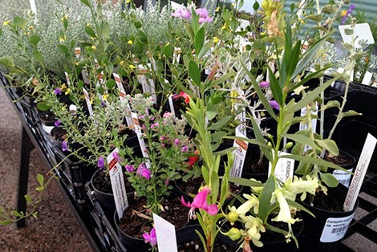

1. What is the ‘Growing Native Gardens’ project?
Planting of trees and shrubs can provide habitat for wildlife once established and shade. A budget has been allocated to this project, to provide support for small, short-term projects ranging up to $300 (GST inc.). This project is funded through the SAAL Landscape Board’s Kingoonya and Marla Oodnadatta district groups.
2. When are the ‘Growing Native Gardens’ funds available?
The ‘Growing Native Gardens’ project will be delivered in 2026. Applications are open from Monday 11th of May until 29th of May. Applications will be assessed and notification of success given within two weeks of applying. There is a fixed amount of funding allocated for this project, once the funds are exhausted the opportunity will cease, so please express your interest quickly if you intend to apply.
Successful applicants will be provided with a gift voucher for the Australian Arid Lands Botanic Garden nursery for $300 (GST inc.).

3. Who can apply?
Applicants need to be located within the Marla Oodnadatta or Kingoonya district www.landscape.sa.gov.au/saal and meet one of the following:
- Community group or associations (i.e. progress associations, sporting clubs such as Glendambo District Sporting Club)
- Kindergarten, pre-school, primary or secondary school
- A not-for-profit organisation
- Publically accessible lands
Applicant needs to ensure they have landholder permission to plant and can plant on-site at school or at a community location.
4. What can be provided?
Purchasing of local native plants. Large equipment, wages, contractors, designs, and planting consumables are not eligible.
5. How to apply?
Applicants fill in the form and return to Tori Love, Community Landscape Officer Kingoonya and Marla Oodnadatta. For further information or to discuss your project, please contact Tori at Victoria.love@sa.gov.au 0408 807 498
6. What happens once an application is submitted?
Applications are assessed against criteria set by SAAL. Applicants will be contacted for any clarification and notified of the outcome of their application within two weeks of submitting the application.
7. What requirements will I have?
Applicants will be responsible for selecting plants, coordinating and establishing a suitable watering and maintenance regime. Please share any photos of works undertaken with Tori from SAAL Landscape Board, and please remember to recognise the SAAL Board in promotion of the plantings.

‘Growing Native Cover Application Form
Contact information
Name of organisation, group or school:
Town:
Contact Name
Phone number Email address

Plant budget
Please outline the number of plants you require and the cost (up to $300 GST inc.)
Number of plants | Cost $ | Supplier *
 | $ | Australian Arid Lands Botanic Gardens  Port Augusta www.aalbg.org/shop
* For 2026, we will provide a gift certificate of $300 for the Australian Arid Lands Botanic Garden, unless otherwise arranged.

Project details
Project location
Location street address
If you are not the property holder, please ensure you have permission for the activity before submitting this form.
Anticipated planting day ___/___/_____

Project description - Briefly outline the area to be planted and the reasons this project is required

Watering, weeds/pests and maintenance plan – outline who is responsible for caring for plants and plans to water and maintain them over the next 12 months while they establish.

Declaration and consent
This section must be completed by an appropriately authorised person on behalf of the applicant organisation (may be different to the contact person listed earlier in this application form).
Name
Signature
Date

Internal Use Only
Selection Criteria
☐ Application within Kingoonya or Marla Oodnadatta District. District boundary: www.landscape.sa.gov.au/saal
☐ Application document correctly filled in
☐ Application within range of amount ($300 GST inc.)
☐ Budget and description within project guidelines

