# Port Augusta – Quorn Landscape Group Newsletter

**October 2024**

*The Port Augusta-Quorn Landscape Group is one of seven district-based groups in the SA Arid Lands region that provides an important link between local communities and the SA Arid Lands Landscape Board. Group members are local people who provide community input into the development and delivery of the board’s five-year plan for the region and help people in their community care for the environment and use natural resources sustainably by building awareness, skills and networks.*

## Landscape Group meeting update

The Port Augusta-Quorn Landscape Group will meet again on Friday 6 December in Quorn. The group will continue planning activities for 2025 at the meeting. If you have an item to raise or would like to attend the meeting, please contact a local member or Community Landscape Officer Brett Devitt on 0409 753 495 or [Brett.Devitt@sa.gov.au](mailto:Brett.Devitt@sa.gov.au)

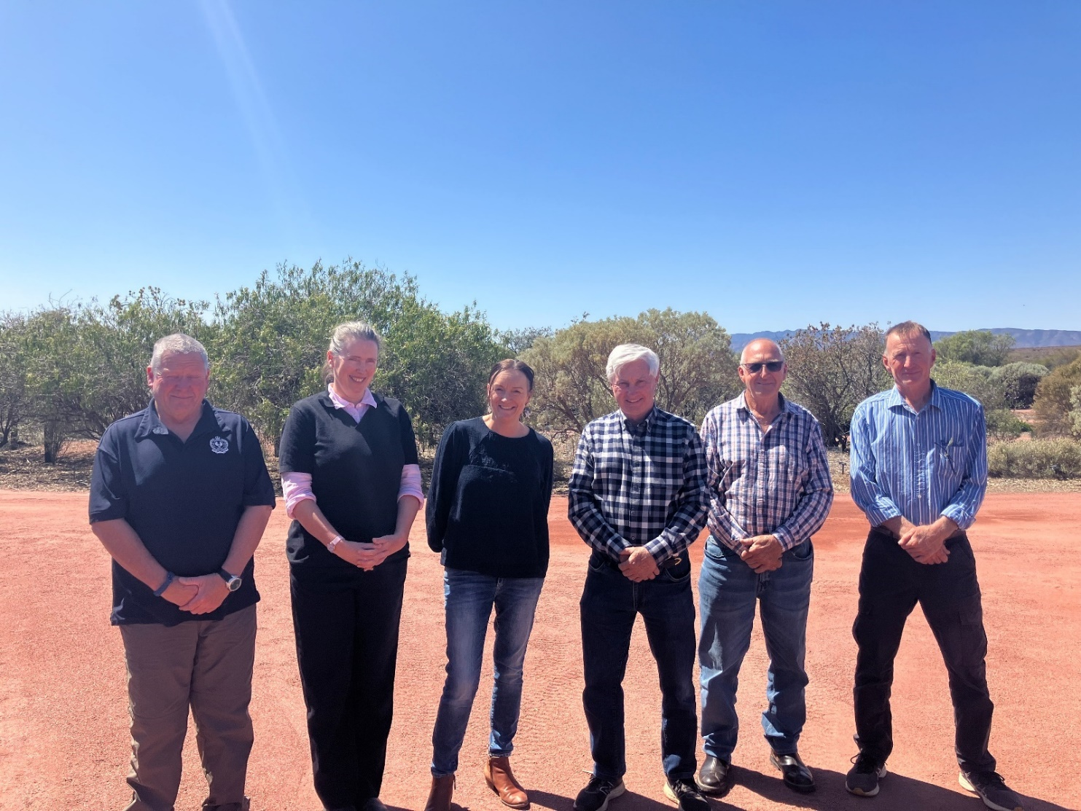Port Augusta-Quorn Landscape Group members at the recent meeting in Port Augusta (L-R) Jeff Bowey, Francene O’Connor, Renatta Hackett, Richie Paynter, Brian Reichelt (guest speaker) and Kurt Tschirner.

**Acknowledgement of Country:** We acknowledge and pay respects to both Barngarla and Nukunu Nations, their elders past, present and emerging, and their strong connection to Country on which the Port Augusta-Quorn district is located.

## Grassroots Grants 2024

Each year the Grassroots Grants program aims to support landholders, volunteers, community groups, not-for-profits and First Nations in local projects that care for our soil, water and biodiversity, while addressing the board’s priorities. Local projects awarded in the Port Augusta-Quorn district include:

* Port Augusta Garden Club will engage speakers to run quarterly workshops focussed on gardening, native flora and fauna, soil, and sustainability.
* Port Augusta Coastcare will host family-friendly *Science in the Pub* community education events to raise awareness of the local coastal environment. The events will focus on restoration of the coastal ecosystems, ecology of coastal plants and reducing pollution.
* Braiden’s Reserve is a reserve established in 2002 to protect False Sandalwood (*Myoporum playcarpum*) and Bullock Bush (*Electryon eleifolius*). The project will install exclusion fencing to give the existing plants opportunity to regenerate and establish new photo monitoring points.
* 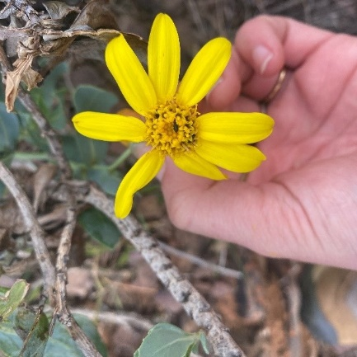Quorn Pioneer Machinery Society’s Avenue of Honour rejuvenation at Lions Park. Established during World War 2, this community project will involve upkeep of the area, and planting seven advanced trees at a community event.
* Threatened Plant Action Group *Superb Groundsel Daisy* (pictured right) monitoring and cultural burn planning with Nukunu. Drone surveys will monitor the nationally vulnerable Superb Groundsel Daisy (*Senecio megaglossus*), revisiting recorded sites and searching for new populations. The Threatened Plant Action Group and Nukunu Wapma Thura will work together to develop a plan for trial cultural/ecological burns.

## Sheep eID day in Quorn

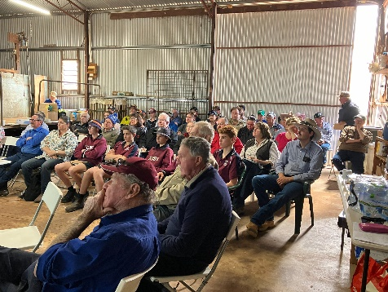Farmers and graziers gathered at the Rodger’s shearing shed on Friday 23 August for a half day sheep EiD workshop.

Adelaide University researchers discussed their local trials of supplementing summer-joined ewes and rams with melatonin and/or vitamin ADE to increase pregnancy rates

Anne Collins outlined the opportunities eID presents in individual animal management, breeding objectives important traits to looks for.

AgTech merchant Datamars demonstrated drafting sheep, based on particular traits using the Rodger’s auto drafter.

Upper North Farming Systems’ Ruth Somerville spoke about the *Regenerating Goyder’s Line* seeding trial, with a walk of a site in Broom Hilder’s paddock to view the results.

Tom Finlay covered predator control, sharing stories from his experience with a trapping demonstration, tips and techniques, plus the benefits of using a thermal scope to optimise control efforts.

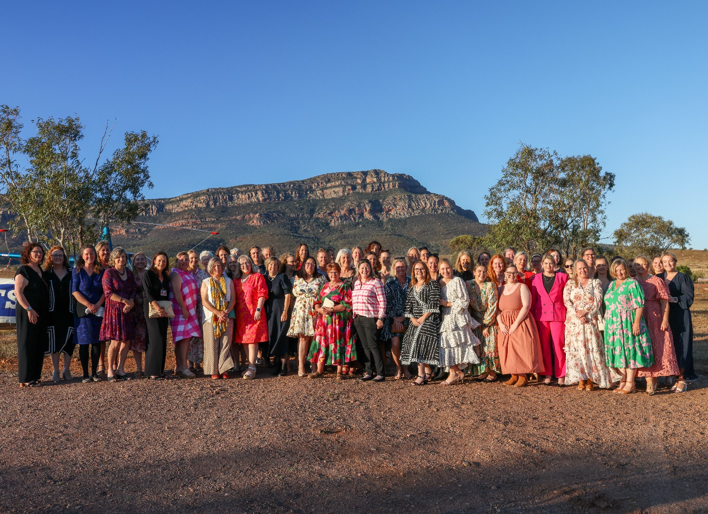

## Outback Ladies Muster

## Women from across the region came together for an exciting event in Hawker during October hosted by the SA Arid Lands Landscape Board. The Outback Ladies Muster was designed to make women feel inspired, find connection, and be empowered. Mia Handshin was the keynote speaker, with presentations from Heidi Wright from Wright Social, Emily Riggs from Iris and Wool, Bridget Johns from Be Simply Free, and founders of the 5431 Collective. There were workshops, dinner and a yoga session which provided an opportunity for the region’s women to connect, build networks and share stories. The event was made possible by funding from FRRR, The Future Drought Fund, BHP and Heathgate Resources.

## 2025 Pastoral Field Day

**The SA Arid Lands Pastoral Field Day returns in 2025. To be held at Port Augusta Racecourse on Thursday 20 March, it will focus on drought preparedness and showcase the latest in AgTech and products, providing a platform for knowledge sharing and opportunities for social interaction.

The event will hear from pastoralists showcasing property trials, guest speakers and trade stalls. There will be on-site demonstrations, and entertainment and activities for children. The event will provide an opportunity to bring families together and will cover topics including climate adaptability, business and personal resilience, community cohesion and will highlight the innovative work happening on pastoral properties across the region.

*The 2025 SA Arid Lands Pastoral Field Day is supported by the Foundation for Rural and Regional Renewal (FRRR), through funding from the Australian Government’s Future Drought Fund.*

## Coming Events

**Wednesday 30 October 5.30pm - Port Augusta Coastcare Meeting**Port Augusta Coastcare meeting at the Old Court House, Jervois St Port Augusta. Contact Brett on 0409 753 495 or email [pacoastcare@gmail.com](mailto:pacoastcare@gmail.com) for more information.

**Saturday 3 November - Birds SA – Port Augusta**Bird watching field trip to Chinamans Creek. Meeting at the Augusta Highway turnoff at 8.00am. Bring binoculars, hat, sun protection, beach shoes and morning tea/lunch. Contact Bernie 0419 863 834.

**Wednesday 20 November 7.00pm - Port Augusta Garden Club**Monthly club meeting at Cnr Elizabeth Tce and Paringa Road. Club contact: Shirley 0439 725 929.

**Saturday 7 December 1.00pm - Friends of the Australian Arid Lands Botanic Gardens**Friends meeting in the conference room of the Australian Arid Lands Botanic Garden.

**Sunday 8 December- Birds SA – Port Augusta**Showing of the year’s best birding photos at the Australian Arid Lands Botanic Garden. Meet in the carpark from 7.30am. Contact Bernie 0419 863 834.

Please contact Brett Devitt if you would like an event added to future newsletters

## Across the Outback

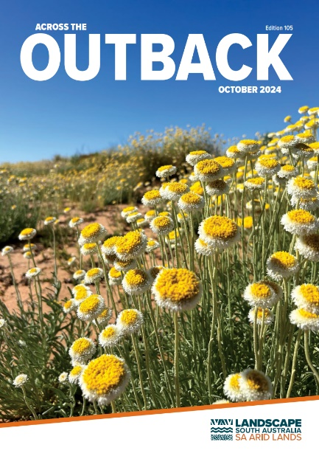The latest edition of the board’s *Across the Outback* magazine includes updates on the board’s many projects and activities, including an achievements report for 2023-24.   
You can download this edition or past copies to read on our [website](https://www.landscape.sa.gov.au/saal/news-resources/publications) or [subscribe](https://www.landscape.sa.gov.au/saal/news-resources/publications/subscribe) to receive your own copy directly in your letterbox or inbox.   
You can also subscribe to receive your own copy on our website.

# Nature Education

## Teacher Professional Development

**A living museum for the natural world.**

****Join Maria Taylor of *Outside the Box Learning* in bringing nature-based learning to life. Two sessions will be held at the Australian Arid Lands Botanic Garden, hosted by the *Friends* of the garden, who have completed their new outdoor learning passport with Maria. This new resource for students is excellent for students to use whilst visiting the garden for excursions. In these sessions you will learn hands-on, practical tips in the sessions, exploring connections with the Early Years Learning Framework and Australian Curriculum priorities.

**Monday 28 October 3.45 -5.15pm**

**Tuesday 29 October 9am -12pm**

**Bookings:** <https://www.trybooking.com/CVYLQ> or follow the QR code

## 

## Growing Native Gardens 2025

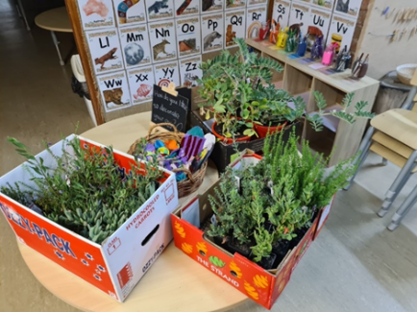Port Augusta-Quorn Landscape Group is excited to continue an opportunity for local schools and community groups in the district to receive up to $300 worth of native plants for planting with students and community group members. Opening in 2025, please keep an eye out on our socials, contact a group member or contact Community Landscape Officer Brett Devitt to express your interest. Applications will be open until 1 April 2025.

## Marine Discovery Centre visits - School Incursions

The very popular Marine Discovery Centre (MDC) will return to Port Augusta in April 2025 to provide school incursions in the district. MDC staff will engage students to learn about coastal and marine environments. These always book out early, so get in touch with Brett if you would like the MDC to visit your class/school.

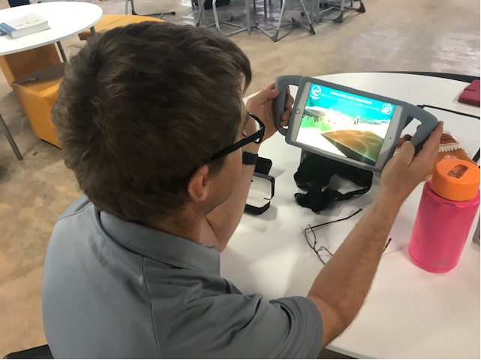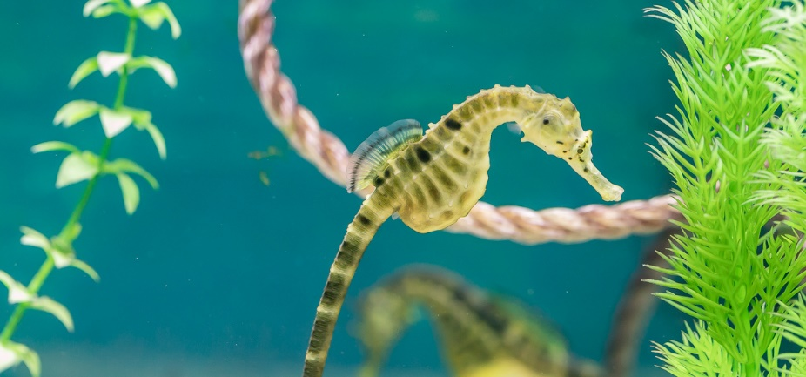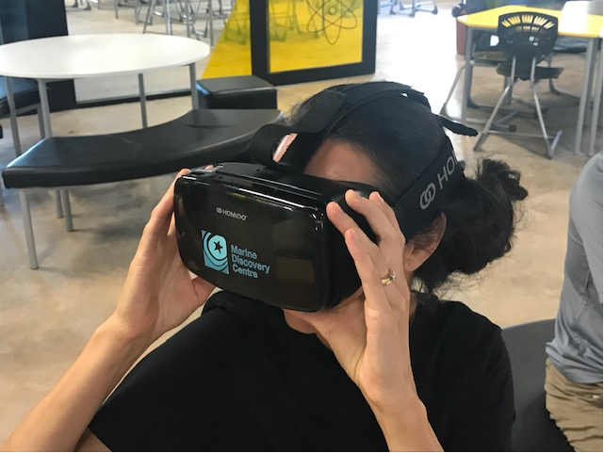

## Authors in Conversation – Sustainability through Stories

Stories are more than just words. Telling stories is how humans make sense of the world and pass on knowledge from one generation to the next. They educate, evoke emotions, shift attitudes, values, and behaviours, and inspire action for change.

A panel of celebrated Australian children's authors recently joined the Green Adelaide team, discussing how to teach sustainability through the magic of children's literature. Learn how the power of storytelling can inspire curiosity and lead to learning experiences that empower young people to take-action for the future. Featuring authors Jackie French, Phil Cummings, and Nola Turner-Jensen.

### [**Access resources**](https://aus01.safelinks.protection.outlook.com/?url=https%3A%2F%2Fdrive.google.com%2Fdrive%2Ffolders%2F17oX9moEiYvHeumvt9cXqwwb0L_YyASqz%3Fusp%3Dsharing&data=05%7C02%7Cbrett.devitt%40sa.gov.au%7Cd7e2b108d9464a52c86008dc9fcc0640%7Cbda528f7fca9432fbc98bd7e90d40906%7C1%7C0%7C638560945852001950%7CUnknown%7CTWFpbGZsb3d8eyJWIjoiMC4wLjAwMDAiLCJQIjoiV2luMzIiLCJBTiI6Ik1haWwiLCJXVCI6Mn0%3D%7C0%7C%7C%7C&sdata=4XooBx6Gs9kUl84cDJtYFPrHXiUxdBLqPNeRP0D2B8o%3D&reserved=0)to support your teaching and learning around our theme including:

### Teacher notes for the books that are discussed

### Articles, guides and useful weblinks

### [**Visit the Green Adelaide YouTube channel**](https://aus01.safelinks.protection.outlook.com/?url=https%3A%2F%2Fyoutu.be%2FllydgAShj9k%3Fsi%3Ds99ec9ABdtcCr97g&data=05%7C02%7Cbrett.devitt%40sa.gov.au%7Cd7e2b108d9464a52c86008dc9fcc0640%7Cbda528f7fca9432fbc98bd7e90d40906%7C1%7C0%7C638560945852012074%7CUnknown%7CTWFpbGZsb3d8eyJWIjoiMC4wLjAwMDAiLCJQIjoiV2luMzIiLCJBTiI6Ik1haWwiLCJXVCI6Mn0%3D%7C0%7C%7C%7C&sdata=rdDjKvhIJfrxFeLyuwJIBhNHuJJt9qKRZKymdFXqikQ%3D&reserved=0)to access the recording of the online PD.

Port Augusta Quorn  
Community Landscape Officer

Brett Devitt   
Email: [Brett.Devitt@sa.gov.au](mailto:Brett.Devitt@sa.gov.au)   
Phone: 0409 753 495

**www.landscape.sa.gov.au/saal**