Applicant name  Where you have a sponsor arrangement, this must be the name of the sponsor organisation who is eligible to apply. | Click here to enter text.
ABN | Click here to enter text.
What type of entity are you?  You may be required to provide proof of incorporation if applicable. | ☐ Incorporated Not-for-Profit organisation  ☐ First Nations organisation  ☐ Non government agency  ☐ Local Government organisation
Have you consulted a Northern & Yorke Landscape Board staff member on your project?  If yes, please provide name. | Select Yes or No  Staff member name: Click here to enter text.
Organisation address | Address Line 1  Address Line 2  Suburb  State  Postcode

Sponsor organisation (where applicable)
Are you applying as a sponsor on behalf of an unincorporated organisation? | Select Yes or No
Sponsored organisation name | Click here to enter text.
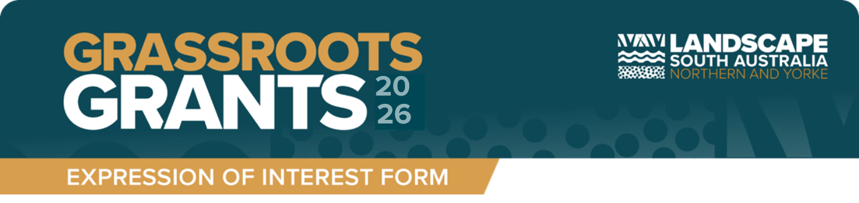
Expressions of Interest submissions close Friday 5pm, 10 April 2026. Please return by email to ny.landscapeboard@sa.gov.au


Applicant details


Nominee Contact Details
Name | Click here to enter text.
Position in organisation | Click here to enter text.
Email address | Click here to enter text.
Telephone number | Click here to enter phone number.
Mobile number  (optional) | Click here to enter mobile number.

Project Information
Project title | Click here to enter text.
Project description (Only basic description required)  What are your key project activities and outcomes? | Click here to enter text. .
Priorities and aligning activities.  Does your project sit under one of the Northern and Yorke Landscape Board Prioirities? (refer to page 4 of the Grassroots Grants Guidelines 2026)  Please select which priorities (more than one can be selected) | ☐ Community  ☐ Biodiversity  ☐ Water  ☐ Sustainable Agriculture  ☐ Pest Plant & Animal Control
Why is the project important? (Less than 250 words) | Click here to enter text.
Project site location  Please ensure the street address is within the Northern and Yorke Landscape Board region | Address Line 1  Address Line 2  Suburb  State  Postcode
Total cost of project | Click here to enter $ amount.
Grant funding sought  Minimum $2,000 and maximum $10,000.  Local Government organisations must provide a minimum of 50% matched funding (in-kind or financial) contributions towards their eligible project. | Click here to enter $ amount.
Can you complete the project by 31st July 2027? | Yes

