Grassroots Grants 2021-22
Frequently asked questions
Contents
What is a legal entity? 2
What is not a legal entity? 2
When would I need to have a sponsor? 2
I am a landholder wanting a grant for works on my property. Can I apply? 2
I run a commercial business. Can I apply? 2
What kind of projects are eligible? 2
What can’t the funding be used for? 3
What are project approvals? 3
Will I need a Water Affecting Activity permit? 3
What level of budget information do I need to provide? 4
Value for money and in-kind? 4
Can I purchase equipment to help me undertake on-ground works? 5
Can I ask for 100% funding or do I have to match it somehow? 5
Will I be able to get an extension past the closing date for a late application? 5
Can I apply more than once? 5
When will I find out if I’ve been successful? 5
How do I register for the Smarty Grants system? 5
How do I use the SmartyGrants Portal? 5
How do I save my application? 6
How do I submit my application? 6
What size documents can I attach to my application? 6
What type of supporting documents do I need to provide 6
What if our whole team needs to work on our application? 6

What is a legal entity?
- Individuals (also known as natural persons)
- Partnerships (made up of two or more individuals)
- Corporations/companies under the Corporations Act 2001 – have a unique ACN and are represented by “Pty”, “Pty Ltd” or “Ltd” following the company name
- Associations – incorporated under the Associations Incorporation Act 1985 (have “Inc.” after their name)
- Trustees in a trust (e.g. John Smith as Trustee for the Smith Family Trust)
- Local Government – under Local Government Act 1999
- Most Australian universities

What is not a legal entity?
- An unincorporated association or group
- A trust (e.g. Smith Family Trust), however the trustees can be. The trustees may be individuals or companies.
- Businesses/business names
- Some private schools. Some of the larger private schools are incorporated or companies, however many are not.
- Public Schools are NOT a legal entity, however the contract would be with the Minister of Education and Child Development, which is a legal entity.

When would I need to have a sponsor?
- If you are not a legal entity, e.g. a group of neighbouring landholders banding together for pest management activities, you will need someone (a person or organisation) to be responsible for receiving and managing grant funding and completing reporting.
- Another common example is an unincorporated Friends of Parks group, who would use Friends of Parks Inc. as their sponsor.
- There is a place in the application form where applicants can upload a sponsorship letter from their sponsoring organisation. A sponsor’s letter is required as part of your application if you are using a sponsor.

I am a landholder wanting a grant for works on my property. Can I apply?
Yes, as an individual you are eligible to apply. However, for your application to be considered for funding, you will need to demonstrate community engagement and the benefit to the broader community. Alternatively, you could apply for funding for a not-for-profit project, in partnership with a community organisation.

I run a commercial business. Can I apply?
Yes, as long as the project is not-for-profit and meets one or more of the priorities laid out in Section 3 of the Guidelines for Applicants.

What kind of projects are eligible?
Not-for-profit, local projects with environmental or sustainable agriculture benefit on Eyre Peninsula. For example:
- weed management (priority will be given to weed management coordinated across neighbouring properties, or weed management with biodiversity outcomes)
- pest or disease management
- fencing of native vegetation or revegetation
- erosion management
- revegetation
- water or wetland management
- sustainable agriculture trials
- educational activities
- raising community awareness and participation in landscape management.
In the project activities section of the application we have included a drop-down menu which lists the standard activities that grantees have undertaken in the past. So have a look through the drop-down list and select the activities that best align to work you propose to do on your project.

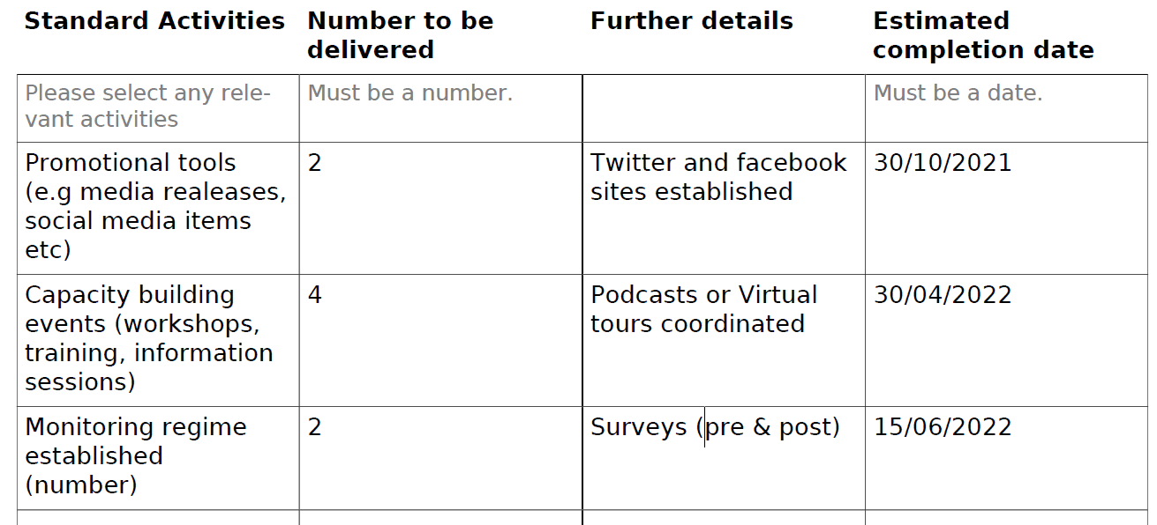

What can’t the funding be used for?
- projects, works or activities already funded by existing or future insurance claims
- activities that are causing or likely to cause environmental damage, either directly or indirectly
- property boundary fencing
- preparation of the grant application
- purchase of machinery, plant and equipment that is not clearly outlined in the application form
- activities that occurred before the grant began, or that have already begun
- project management and administration costs of the applicant which are not related to the project and do not appear in the project budget table in the application form
- routine administration expenses, including, but not limited to, office rental, office computing facilities, legal and accounting fees and bank charges.
- existing debts or shortfalls
- marketing and promotion of the organisation or existing services (unless directly associated with the project and educational in nature)
- activities that are unlawful.

What are project approvals?
The application will prompt you to provide details of any approvals that might be required for your project and whether these approvals have actually been granted or not. Depending on what activities you are proposing to underrate these could vary significantly and, might include approvals such as:
- Landholder/landowner permission
- Aboriginal heritage or Native Title approval
- Water Affecting Activities
- Native vegetation clearance
- Coastal Development or Crown Lands approvals
- Council or development approval
- Other (where you can specify any ‘other’ approvals you might need).

Even if you don’t have the approvals yet, these should be included in your applications (and your work plan and budget should factor in the costs or timeframes associated with getting the approvals, if needed). Non-disclosure of any relevant approvals could impact on the assessment of your project.

Will I need a Water Affecting Activity permit?
You will need to check if your project is a Water Affecting Activity (WAA). Typical activities that may require a WAA permit include dam construction, construction works in a watercourse, (e.g. culvert crossings, excavation for drainage works, erosion control and well construction). If a permit is required, this will be need to be identified in the application, along with any appropriate conditions. Board staff will assist applicants to apply for a permit as part of the grant approval, however grant funding will be subject to approvals being gained. For more information please go to: https://www.landscape.sa.gov.au/ep/Water/water-affecting-activities or ring your local Landscape Officer to determine if a WAA permit is required.

What level of budget information do I need to provide?
In your application you will need to provide details of all project income you think you will receive for the project (including the grant funds you are requesting), as well as details of all project expenditure. Below is a hypothetical example of how this can be achieved. Please note that the total income and expenditure will be added up automatically and your budget will need to balance.
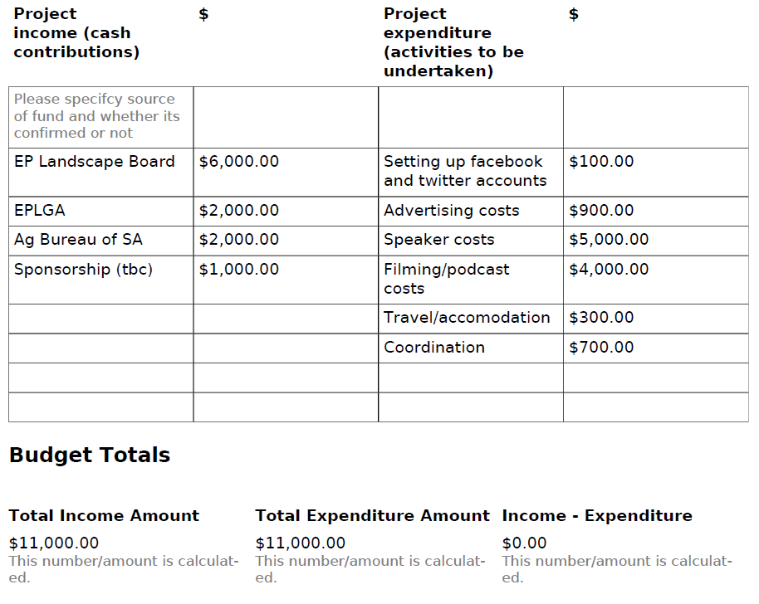
All amounts should be GST exclusive. A 'gross up' of 10% GST will be applied by the Board
to the approved amount (where an applicant or sponsoring organisation is registered for
GST).

Value for money and in-kind?
In the assessment process, one of the criteria that your project will be assessed against is value for money, so it is important that you capture any cash or in-kind contributions to your project in your application.
Cash contributions need to be captured in the budget table. This should include any cash you or your organisation are contributing, the amount of grant funds you are requesting from the Board, as well as any cash that you will get from other partners.
In-kind contributions are requested in a separate question in the application. Please ensure you list all of the non-monetary support that you will provide to the project or you will get from other partners, and then estimate what the value of this in-kind support might be. For example the hypothetical example above the following in-kind contributions might apply:
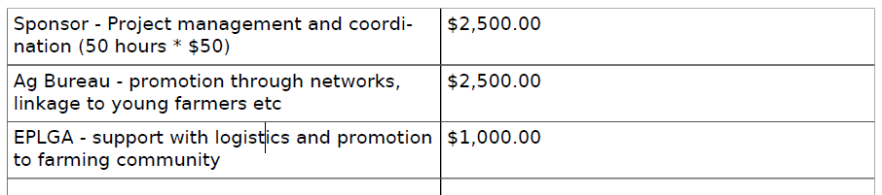

Can I purchase equipment to help me undertake on-ground works?
Generally, funding is not provided for the purchase of major assets, however, purchase of minor equipment may be considered if it can be demonstrated that this is essential to the delivery of specified works. Please ensure that you provide details of any capital costs and assets in your application form that are valued at more than $500. For major assets, you are encouraged to borrow or hire equipment rather than purchasing them.

You can discuss major equipment requirements with a landscape officer to determine whether there is any equipment the EP Landscape Board may be able to provide on loan for the project.

Can I ask for 100% funding or do I have to match it somehow?
You can ask for your project to be fully funded, however, it may affect your assessment score (see Section 6 of the Guidelines for applicants). If you are unable to identify any other cash contributions to your project, you may still be able to demonstrate value for money by including in-kind contributions.

Will I be able to get an extension past the closing date for a late application?
No, the online SmartyGrants portal will close at 5.00pm on 9 June 2021.

Can I apply more than once?
Yes, as long as the projects are separate and distinct and you or your organisation has the capacity to deliver them.

When will I find out if I’ve been successful?
It is anticipated that the assessment and approvals process will take approximately four weeks. All applicants will be advised whether or not their proposed project(s) were successful by 30 June 2021. Grant Agreements will then be sent to successful proponents.

How do I register for the Smarty Grants system?
Before you can start completing your application, you will need to register on the SmartyGrants portal. Registration gives you secure access to your forms allowing you to work on them over time rather than having to complete them all at once.

It only takes a moment to register and you can get started on your submission straight after registering. Just follow the link you have been provided to fill in the registration section (you will just need to provide your name, email address and a secure password).

How do I use the SmartyGrants Portal?
On every screen (page of the form) you will find a Form Navigation contents box that links directly to every page of the application. Click the link to jump directly to the page you want. You can also click 'next page' or 'previous page' on the top or bottom of each page to move forward or backward through the application.

If you need more help using the SmartyGrants portal, download the Help Guide for Applicants or check out Applicant Frequently Asked Questions (FAQ's)

How do I save my application?
If you wish to leave a partially completed application, press 'save and close' and log out. When you log back in and click on the 'My Submissions' link at the top of the screen, you will find a list of any applications you have started or submitted. You can reopen your draft application and start where you left off. You can also download any application, whether draft or completed, as a PDF. Click on the 'Download PDF' button located at the bottom of the last page of the application form.

How do I submit my application?
You will find a Review and Submit button at the bottom of the Navigation Panel. You need to review your application before you can submit it. Once you have reviewed your application you can submit it by clicking on 'Submit' at the top or bottom of the screen or on the navigation panel. You will not be able to submit your application until all the compulsory questions are completed and there are no validation errors. Once you have submitted your application, no further editing or uploading of support materials is possible.

When you submit your application, you will receive a confirmation email with a copy of your submitted application attached. This will be sent to the email you used to register.

If you do not receive a confirmation of submission email then you should presume that your submission has NOT been submitted.
Hint: also check the email hasn’t landed in your spam or junk email folder.

What size documents can I attach to my application?
You may need to upload/submit attachments to support your application. This is very simple, but requires you to have the documents saved on your computer, or on a storage device. You need to allow enough time for each file to upload before trying to attach another file. Files can be up to 25MB each; however, we do recommend trying to keep files to a maximum of 5MB – the larger the file, the longer the upload time.

What type of supporting documents do I need to provide
Throughout the application there are sections were you can upload further information to support your application, this includes the following documents:
- A copy of your (or your sponsors) current insurance policy
- Additional project detail information, for example specific site maps, project plans, letters of support, quotes for on-ground works etc.
- Evidence of any project approvals that you have received.

We recommend that you upload any documentation that you can that might support your application through the assessment process.

What if our whole team needs to work on our application?
A number of people can work on an application using the same log-in details as long as only one person is working at a time. Ensure you save as you go.

