Consultants Badging

Native Vegetation Clearance

<Proposal – Report Title>

Level 1 - Data Report

Clearance under the Native Vegetation Regulations 2017
<Date>
Prepared by <NVC Accredited Consultant>
Example photo

<Delete all instructional and example text in Red>

Reports, ESRI shapefiles, photos and attachments are to be submitted through the Native Vegetation Online Application Portal accessed at https://apps.environment.sa.gov.au/nvmu/. Files must be:
• PDF format (no scans)
• PDF must be searchable and copyable

1. Application information
Application Details
Applicant: | Name
Key contact: | Name and contact details
Landowner: | If the applicant is not the landowner, written permission must be provided
Site Address: | e.g. 1 Smith Street, Smithtown
Local Government Area: |  | Hundred:
Title ID: | CT  CR  CL | Parcel ID | Sec  DP A/Q  FP A/Q

Summary of proposed clearance
Purpose of clearance | e.g. Clearance required for the construction of a house, vehicle access and ancillary structures including a shed and rainwater tank
Native Vegetation Regulation | e.g. Regulation 12, Schedule 1; clause 33, House or Buildings
Description of the vegetation under application | Size, type and general condition - e.g. 1.25 ha of Stringybark (Eucalyptus obliqua) Woodlands in good condition and 5 large healthy Blue Gum (Eucalyptus leucoxylon) trees.
Total proposed clearance - area (ha) and number of trees | e.g. 0.72 ha and 5 scattered trees are proposed to be cleared.
Level of clearance | Level 1
Overlay (Planning and Design Code) | Native Vegetation Overlay or State Significant Native Vegetation Overlay (for applications associated with a development application only)
Map of proposed clearance area (show as a minimum; property boundary and proposed clearance area)
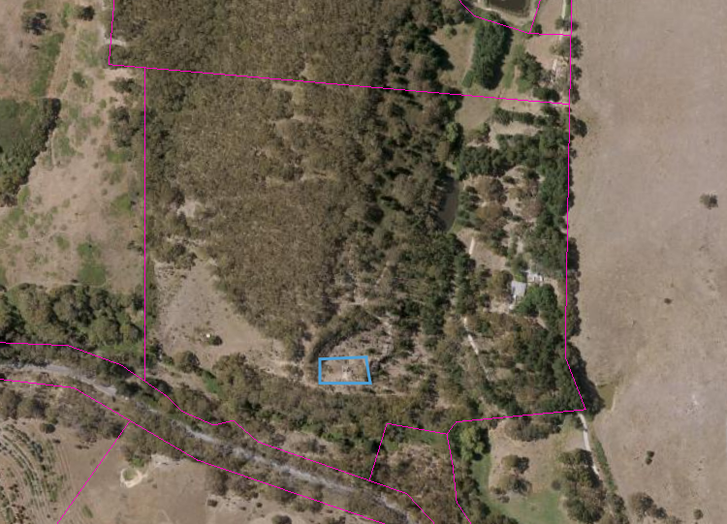
Mitigation hierarchy | The consultant must briefly describe the steps that have been taken to avoid and then minimize impacts.
SEB Offset proposal | Payment of $500

2. Purpose of clearance
Details of the proposal
Provide specific information relating to the proposal, particularly any design plans and drawings and proposed layout.
Where possible, the design plan and drawings should be overlaid on an aerial image with the vegetation proposed to be impacted identified. Geo located files can be provided with the application.

3. Vegetation
Details of the vegetation associates/scattered trees proposed to be impacted
For each patch of vegetation, provide the following;
Vegetation Association | (e.g. Vegetation Association 1; Eucalyptus odorata open woodland).
Representative photo(s)
- Provide direction and location of the photo(s)

General description | e.g. dominant species, condition and observations of disturbance
Flora species | List the flora species present (e.g. Eucalyptus porosa, Acacia pycnantha, etc.)
Area (ha)

For each scattered tree or patch of trees present, provide the following;
Tree ID – e.g. Tree 1 or Cluster 1 | Representative photo(s)  - Provide direction and location of the photo  - Show full extent of tree, plus range pole
Tree spp. (e.g. Eucalyptus odorata)
Number of trees – If a cluster
Height (m) –
Hollows – (e.g. 1 large, 0 medium and 3 small)
Diameter (cm) –
General comments relating to the condition or value of the trees

4. Requirements
Address the Mitigation Hierarchy
When exercising a power or making a decision under Division 5 of the Native Vegetation Regulations 2017, the NVC must have regard to the mitigation hierarchy. The NVC will also consider, with the aim to minimize, impacts on biological diversity, soil, water and other natural resources, threatened species or ecological communities under the EPBC Act or listed species under the NP&W Act.
Describes the steps that have been taken to firstly avoid and then minimize impacts on native vegetation.
      - Avoidance
e.g. making adjustments to the location, design, size or scale of the activity in order to reduce the scale of the impact.

      - Minimization
e.g. located the development in area where vegetation is sparser or more degraded or does not contain threatened species, etc.

      - Rehabilitation or restoration
e.g. if clearance is only temporary, actions take to re-establish the vegetation after clearance has occurred.

      - Offset
Level 1 applications will achieve an SEB requirements via a payment of $500 into the Native Vegetation Fund.
Risk Assessment
Determine the level of risk and provide information to support the risk assessment
Agricultural Areas (EP, GA, H&F, KI, LC, M&R and N&Y Landscape Management Regions plus Port Augusta City Council and the Flinders Ranges Council). | Yes / No
Is the area of proposed clearance greater than 500m²?
Does the proposed clearance involve more than five scattered trees?
Does the proposed clearance involve any trees with a trunk circumference measured at 1m above the ground of (for multi stemmed trees, measure the largest trunk/stem): 50cm or more?
Does the proposed clearance involve any listed flora species under the NP&W Act or threatened flora species or community under the EPBC Act?

Or (delete the table that is not applicable)
Pastoral Areas (SAAL and AW Landscape Management Regions excluding Port Augusta City Council and the Flinders Ranges Council). | Yes / No
Is the area of proposed clearance greater than 3ha?
Does the proposed clearance involve more than five scattered trees?
Does the proposed clearance involve any trees with a trunk circumference measured at 1m above the ground of (for multi stemmed trees, measure the largest trunk/stem): 30cm or more?
Does the proposed clearance involve any listed flora species under the NP&W Act or threatened flora species or community under the EPBC Act?

If the response to any of these questions is yes, then the clearance is NOT a level 1 clearance and this data report is not applicable.

5. Significant Environmental Benefit
A Significant Environmental Benefit (SEB) is required for approval to clear under Division 5 of the Native Vegetation Regulations 2017. The NVC must be satisfied that as a result of the loss of vegetation from the clearance that an SEB will result in a positive impact on the environment that is over and above the negative impact of the clearance.

The SEB is to be achieved by making a payment into the Native Vegetation Fund of $500.

