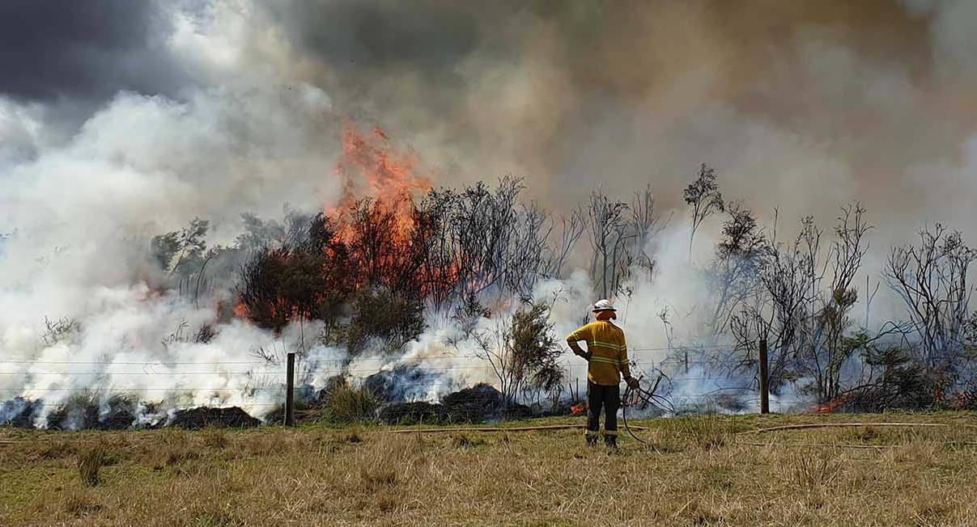

Basic Management Plan
Ecological prescribed burning under Native Vegetation Regulation 11, Schedule 1, Clause 25

When to use this Management Plan
Please use this template as a guide to assist you prepare a management plan for ecological burns.
A Management Plan must be submitted to the Native Vegetation Council (NVC) to be assessed against the Guideline for Ecological Prescribed Burning under Native Vegetation Regulation 11, Schedule 1, Clause 25. This Basic Management Plan is recommended to be used in the following circumstances:
- Proposed burn is less than 0.5ha; or
- IBRA Association remnancy is more than 20%.
If assistance is needed in preparing a Management Plan, please contact the Native Vegetation Branch.

Who is involved?
Applicants must be the owner of the land or someone authorised to act on the landowner’s behalf. Provide details of the personnel involved in undertaking the burn including suitable experience details.
Applicant details | Name:
Applicant details | Mobile:
Applicant details | Email:
Applicant details | Indicate in what capacity you are applying | ☐ Private Landholder  ☐ Authorised individual (applying on behalf of a Landholder)
Operational personnel | Name and role:
Operational personnel | Name and role:
Operational personnel | Name and role:
Permits / CFS liaison | Permits obtained (if required):
Permits / CFS liaison | CFS liaison details: | While not required, if the CFS has provided advice or is involved in supplying any equipment or support, please provide an indication of their involvement.

Where is the planned burn?
Provide details of where the prescribed ecological burn will take place, including all land parcels and details of specific assets eg. dwellings, agricultural buildings. Please attach a map which identifies the planned burn area(s), any firebreaks, vegetation associations, road names and land parcels boundary details.
Land details | Title | Parcel ID | Asset notes

What is the context?
Include information about the current context. Please attach a representative photo for each site and Vegetation Association.
Landscape | Description (eg. land uses, topography, access, past fire history)
Vegetation Association(s) | Description | Conservation values |  | Condition | Area to be burnt (ha)
Threatened flora or fauna | Species and conservation status | Fire response | Mitigation actions

What is planned?
Provide details on the scale, timing, method of burning which is proposed. Describe the ecological objectives for the prescribed burn across each site and the follow-up monitoring which is planned.
 |  | Site 1 | Site 2 | Site 3

Size (ha)
Strategy / regime | Low intensity  Medium intensity  High intensity | ☐  ☐  ☐ | ☐  ☐  ☐ | ☐  ☐  ☐
Strategy / regime | Summer  Autumn  Winter  Spring | ☐  ☐  ☐  ☐ | ☐  ☐  ☐  ☐ | ☐  ☐  ☐  ☐
Strategy / regime | Frequency / interval | ……………………………………………… | ………………………………………… | …………………………………………
Strategy / regime | Mosaic (several patches) | ☐ | ☐ | ☐
Strategy / regime | Patch (single patch) | ☐ | ☐ | ☐
Ecological objectives | Regeneration of plant species | ☐ | ☐ | ☐
Ecological objectives | Species diversity | ☐ | ☐ | ☐
Ecological objectives | Germination of soil seed bank | ☐ | ☐ | ☐
Ecological objectives | Establish or support threatened species | ☐ | ☐ | ☐
Ecological objectives | Establish vegetation age classes | ☐ | ☐ | ☐
Ecological objectives | Improve vegetation structure | ☐ | ☐ | ☐
Ecological objectives | Restore swamp biodiversity | ☐ | ☐ | ☐
Ecological objectives | Reduce weed cover | ☐ | ☐ | ☐
Ecological objectives | Other – please describe

How will you monitor the effects of the clearance?
Provide details about the monitoring program to assess the effects of the burn in relation to the ecological objective(s) outlined in the plan.
You may consider undertaking some of the following:
- photo points of the vegetation (referencing location, direction, date and observations) at pre-burn and yearly post-burn intervals
- list of management actions completed to mitigate weed and pest invasion
- self-evaluation of the achievement of stated ecological objectives, for example:
  - vegetation diversity survey
  - regeneration
  - weed cover scores.

Annual monitoring of burns sites (post fire weed control, management and level of regeneration)
Annual reporting (minimum 3 years)
Post-fire report (within 28 days) (type of fire and actual area burnt)

How will the risk be managed?
Please describe how the risk will be managed. Please include ecological risks, as well as risks to life, built and cultural assets.

Risk assessment* | Mitigation
Fire containment e.g. breaks
Loss of species / biodiversity
Weed / pest invasion
Introduction of Phytophthora
Others – please specify
*List the risks associated with the entire proposal (i.e. not each site individually) and consider the mitigation strategies to reduce the risks.

Attachments
- Please attach a map which identifies the planned burn area(s), any firebreaks, vegetation associations, road names, land parcel boundary, and any significant ecological features.
- Please attach a representative photo for each site and Vegetation Association.

References
- Ecological Fire Management Guidelines for Native Vegetation in South Australia, Department for Environment, Water and Natural Resources, April 2013
- Ecological Prescribed Burning under Regulation 11(25) Guideline, Native Vegetation Council

More information
Native Vegetation Branch
Department for Environment and Water
T (08) 8303 9777
E nvc@sa.gov.au
www.environment.sa.gov.au/nativevegetation

Appendix 1
Ecological Fire Management Guidelines for each fire-prone Major Vegetation Sub-group (MVS) in South Australia (Extract of Ecological Fire Management Guidelines (DEWNR, 2013))
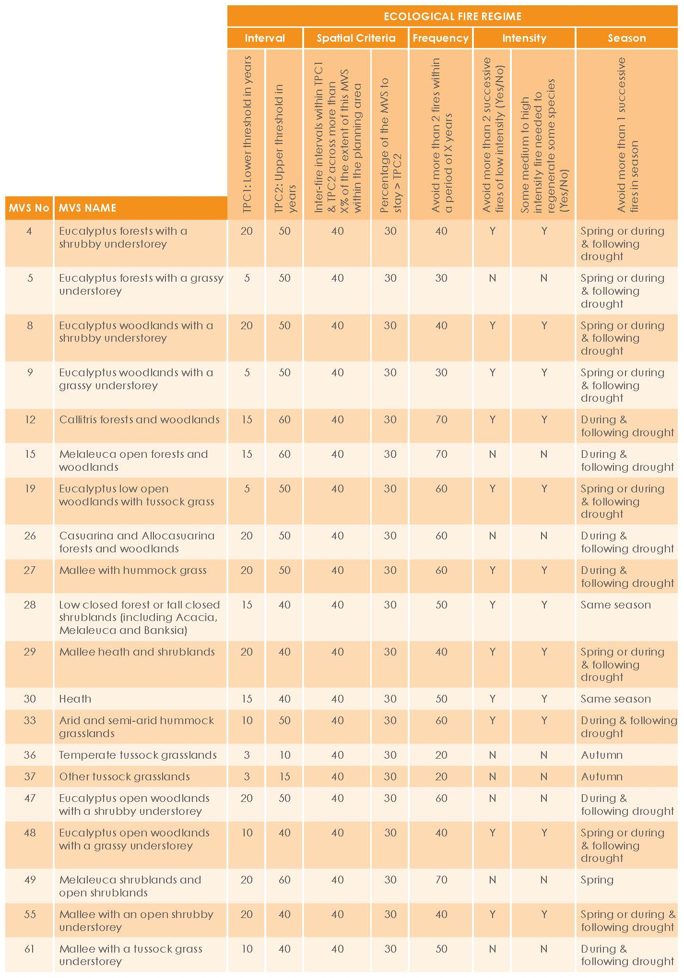


Published by the Department for Environment and Water.
Government of South Australia
September 2023
Report prepared by:
Department for Environment and Water
Native Vegetation Branch
Environment, Heritage and Sustainability Directorate
www.environment.sa.gov.au


With the exception of the Piping Shrike emblem,
other material or devices protected by Aboriginal
rights or a trademark, and subject to review by the
Government of South Australia at all times, the content
of this document is licensed under the Creative Commons
Attribution 4.0 Licence. All other rights are reserved.
© Crown in right of the State of South Australia

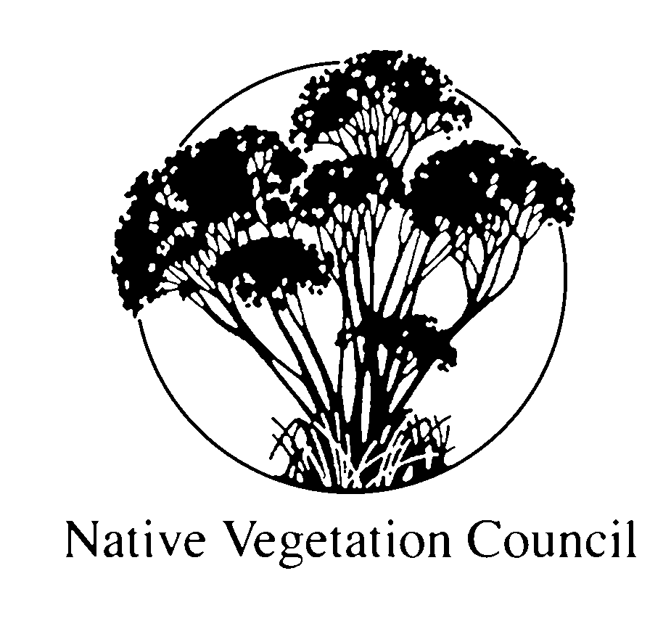

Where burning is proposed within the State’s agricultural districts, refer to Appendix 1
For example: positive, expected to trigger growth or germination; or negative, species relies on old growth mall vegetation

