
Native Vegetation Council AOFcFcICrIAeLdited Consultants
Contact consultants to enquire about their service for clearance applications, vegetation assessments and other associated works. Please note that not all consultants undertake all application and assessment types or service all regions of the South Australia. Work undertaken is at the consultant’s discretion. A landscape region key and map is on the final page of this document.
List updated January 2026

Company | Consultant Name and Role | Contact details | Regions Serviced
Acacia Park Consulting | Kurt Tschirner  Partner | Quorn SA 5433  Mobile: 0493 262 975  Email: tschirnerkurt@gmail.com | SAAL EP  N&Y
Aenigma Natives | Michelle Haby  Senior Botanist | PO Box 639 Kingscote SA 5223  Website: https://www.aenigmanatives.com.au  Mobile: 0407 619 229  Email: michelle@aenigmanatives.com.au | KI
Amenti Environmental Australia Pty ltd | Tobias Scheid Director/Principal Ecologist  Sarah Stevens  Senior Ecologist  James Garden  Ecologist | Website: Amenti Environmental Australia  Mobile: 0421 644 493  Email: tobias@amenti.com.au  Mobile: 0408 640 879  Email: sarah@amenti.com.au  Email: James@amenti.com.au | All of SA
Anne Brown | Anne Brown  Independent Consultant | West Terrace, Wirrabara SA 5481  Mobile: 0409 684 312  Email: anne@annebrown.au | N&Y SAAL
Au2100 | Dr Kerri Muller  Principal | Ph: 0428 211 271  Email: klm@au2100.com.au  Clearance for ecological restoration only | All of SA
Australian Integrated Carbon Pty Ltd | Hafiz Stewart  Head of Science and Innovation | Pulteney St, Adelaide SA 5000 Website: https://aicarbon.com/  Mobile: 0448 894 230  Email: hafiz.stewart@aicarbon.com | All of SA
Barron Environmental | Phil Barron  Principal / Sole Trader | PO Box 1122, Mount Barker, SA, 5251  Mobile: 0435 546 069  Email: barron.environmental@outlook.com | All of SA
BlackOak Environmental | Matt Launer  Environmental Consultant | Streaky Bay SA 5680  Website: www.blackoakenvironmental.com  Mobile: 0484 914 580  Email: matt.launer@blackoakenvironmental.com | EP SAAL  N&Y AW
COOE – Care of our Environment | Dr Lindy Scott  Senior Ecologist Consultant | PO Box 591, Littlehampton SA 5250  Website: Services | Environmental Services - Care of Our Environment  Ph: 08 8339 8515 | H&F SAAL

Mobile: 0431 681 163
Email: lindy.scott24@gmail.com
Debill Environmental | Dr Kathryn Hill  Plant Ecophysiologist | Website: https://www.debillenvironmental.com.au/  Mobile: 0423 693 733  Email: kathryn@debillenvironmental.com.au | All of SA, excluding SAAL
Donato Environmental Services | David Donato  Director | PO Box 175 Athelstone SA 5075  Mobile: 0417 819 196  Email: ddonato@rbe.net.au
Ecological Associates Pty Ltd | Dr Marcus Cooling  Principal Ecologist  Renate Faast  Senior Ecologist | 65 Flinders Street Adelaide SA 5000 Website: https://www.eassoc.com.au  Ph: 8272 0463  Mobile: 0403 775 475  Email: mcooling@eassoc.com.au  Email: rfaast@eassoc.com.au Mobile: 0429 177 371 | EP  H&F KI LC  ML&RL  N&Y SAAL
Ecosphere Ecological Solutions Pty Ltd. | Andrew Sinel Managing Director/Technical  Director | 4/112 Main Road, McLaren Vale, SA Website: www.ecosphere.solutions Company mobile: 0448 685 658  Mobile: 0400 555 855  Email: andrew@ecosphere.solutions | All of SA
EnviRO Environmental | Rohan Calley  Independent Consultant | Angaston SA 5353  Ph: 0417 00 99 22  Email: ro@enviroenvironmental.com.au | All of SA
Environments by Design | Wayne Brown Principal Environmental Consultant | PO Box 62 Bridgewater SA 5155  Website: http://environmentsbydesign.com.au/  Office Ph: 08 8389 2125  Mobile: 0408 813 628  Email: wayne@environmentsbydesign.com.au | EP  H&F KI LC  ML&RL  N&Y
Far West Coast Aboriginal Corporation | Gregory Cramond  Ranger Manager | 62 Poynton Street, Ceduna SA 5690 Website: www.farwestcoastaboriginalcorp.org.au  Mobile: 0438 105 097  Email: greg@fwcac.org.au | AW
GBS Consulting | Greg Smith  Owner/Ecologist | Bellevue Heights, SA 5050 Mobile: 0418 971 967  Email: gregorsmith@internode.on.net | All of SA
GHD | Sjaan Bidwell  Technical Director –  Botany | Lonsdale street Melbourne Victoria 3000 Victoria Square, Adelaide SA 5000  Mobile: 0418 120 963  Email: sjaan.bidwell@ghd.com | All of SA
Grant Fleming Environmental | Grant Fleming  Principal Environmental  Scientist | Rowland Road Magill SA 5072 Website: www.gfenvironmental.com.au | All of SA

Ph: 0448 600 767
Email: grant.fleming@gfenvironmental.com.au
Iluka Resources | Jade Zander  Rehabilitation Specialist | Mobile: 0427 549 504  Email: j.r.adams@live.com.au | AW SAAL
J Diversity Pty Ltd | James Brook  Principal/Director | Mobile: 0417 822 705  Email: jbrook111@gmail.com  Marine ecological surveys only | All of SA
JA Pedler Environmental Consultant | Janet Pedler | Ph: 0438 884 384  Email: jpedler@senet.com.au | All of SA
Jacobs Group (Australia) Pty Ltd | Emma Eichler  Associate Ecologist  Shelley Greer  Senior Ecologist | 121 King William Street Adelaide SA 5000 Website: Welcome to Jacobs | Jacobs  Mobile: 0458 407 501  Email: emma.eichler@jacobs.com  Mobile: 0499 439 253  Email: Shelley.greer@jacobs.com | All of SA
Jeremy Ross-Carter | Jeremy Ross-Carter  Independent  Environmental Consultant | Forestville SA 5035  Mobile: 0412 671 838  Email: jeremyrosscarter@gmail.com | All of SA
JS Ayre & Associates | Jackie Ayre  Principal | PO Box 123 Edwardstown SA 5039  Mobile: 0416 151 234  Email: ayrejackie60@gmail.com  Also, level 5 Qualified arborist | H&F, KI, N&Y, LC
Kelly Menadue Earth Wind Fire Consulting | Kelly Menadue  Senior Environmental Consultant | GPO Box 1671 Adelaide SA 5000  Ph: 0417 807 616  Email: kelly_menadue@yahoo.com.au
Lathwida Environmental | Dr Nicholas Bull Director, Principal Ecologist  Katie Fels Senior Associate Environmental Consultant  Zeta Bull  Principal Ecologist | 72/76 Edmund Ave Unley SA 5061 Website: Lathwida Environmental  Mobile: 0439 893 240  Email: Nicholas.Bull@lathwida.com  Mobile: 0414 293 603  Email: Katie.Fels@lathwida.com  Email: zeta.bull@lathwida.com | All of SA
Miles Environmental Pty Ltd | Catherine Miles  Director | PO Box 680, Nairne, SA 5252  Mobile: 0408 640 377  Email: cm@milesenvironmental.com.au | EP, H&F, KI, LC, ML&RL,  N&Y
Mister Tucker’s Business | Peter Tucker  Principal Consultant | Naracoorte SA  Mobile: 0428 540 598 | LC

 |  | Email: Mister.tucker@bigpond.com
Neil Collins | Neil Collins  Independent Assessor | Aldgate  Ph: 0417 879 104  Email: Neil.collinsnrm@gmail.com | AW, EP, H&F, ML&RL,  N&Y, SAAL
Neoxena Research | André Ortiz  Principal Scientist & Ecologist | 55 Exchange Place, Adelaide SA 5000 Website: https://neoxenaresearch.com.au/  Ph: 0434 851 242  Email: andre@neoxenaresearch.com.au | All of SA
Plant Tactics | Jacob Kochergen  Principal | PO Box 317, Lobethal, SA 5241  Website: Native Vegetation Services – Plant Tactics  Ph: 0452 186 041  Email: jacob@planttactics.com | All of SA
RSW Environmental | Russell Seawright  Managing Director | Waite Campus, Hannaford, Urrbrae SA 5064 Website: https://rswenvironmental.com.au/  Mobile: 0411 759 567  Email: info@rswenvironmental.com.au | All of SA
SLR Consulting Australia Pty Ltd | Matthew Jones Technical Director – Environmental Management, Permitting & Compliance  Louise Jaunay  Associate Consultant –  Ecology & Biodiversity | P.O Box 854, Nuriootpa SA 5355 Website: Global Leaders in Sustainability Solutions | SLR Consulting  Mobile: 0434 070 447  Email: Matthew.jones@slrconsulting.com  Ph: 8562 4158  Email: Louise.jaunay@slrconsulting.com | All of SA
Succession Ecology | Dr Briony Horner CEO, Director, and Principal Ecologist  Glenn Christie Director and Revegetation  Consultant | Unit 1/938 South Road, Edwardstown, SA 5039 Website: www.successionecology.com.au  Ph: 08 8166 2648  Mobile: 0410 526 210  Email: briony@successionecology.com.au  Mobile: 0409 282 096  Email: glenn@successionecology.com.au | All of SA

 | Dr C. E. Timothy Paine  Ecology Team Manager  Dr Sabine Both Research and Development Coordinator  Dr Julie Schofield  Ecologist  Doreen Marchesan  Ecologist  Dr Andrea Stiglingh  Ecologist | Ph: +61 (0) 444 502 228  Email: tim@successionecology.com.au  Mobile: 0444 500 860  Email: sabine@successionecology.com.au  Mobile: 0414 747 847  Email: julie@successionecology.com.au  Mobile: 0432 799 272  Email: doreen@successionecology.com.au  Email: andrea@successionecology.com.au
Swainsona Seed Services | Alice Quarmby  Principal Environmental  Consultant | Mobile: 0438 453 119  Email: alice@swainsonaseedservices.com.au | All of SA
Terra Gana Pty Ltd | Sheree Edwards Director and Senior Consultant  Matthew Humphrey Director and Senior Consultant | Website: www.terragana.com.au Adelaide Hills and Riverland, SA  Mobile: 0422 468 996  Email: admin@terragana.com.au  Mobile: 0448 847 998  Email: admin@terragana.com.au | All of SA
Umwelt | Travis How  Regional Manager SA  Marina Louter  Principal Ecologist  Emma Tremain Senior Environmental Consultant  Jesse Carpenter  Principal Ecologist  Jessica Skewes  Principal Ecologist  Angela Carpenter  Senior Ecologist | SA office based in Torrensville SA, 5031, Website: www.umwelt.com.au Company ph: 1300 793 267  Email: travis.How@umwelt.com.au Mobile: 0419 141 247  Email: marina.Louter@umwelt.com.au Mobile: 0427 141 000  Email emma.tremain@umwelt.com.au  Email: jesse.carpenter@umwelt.com.au  Email: Jessica.skewes@umwelt.com.au Mobile: 0429 016 417  Email: angela.carpenter@umwelt.com.au Mobile: 0408 938 430 | All of SA

 | Ella West  Ecologist | Email: Ella.West@umwelt.com.au
West Coast Revegetation | Phil Landless  Director | Carpenter Court, Ceduna SA 5690  Mobile: 0488 648 381  Email: pglandless@gmail.com | EP AW  N&Y
WSP Australia |  | Pirie Street, Adelaide, 5000  Website: WSP | Global engineering and professional services firm | WSP | All of SA
 | Hayley Merigot  Senior Ecologist | Ph: 08 8110 9554  Email: hayley.merigot@wsp.com
 | Ned Piscioneri  Senior Ecologist | Ph: 08 8213 2111  Email: ned.piscioneri@wsp.com
 | Tia Gabruch  Ecologist  Justin Pegg  Associate Ecologist | Email: tia.gabruch@wsp.com  Melbourne. Victoria. 3000 Email: justin.pegg@wsp.com
 | Nick McCaffrey  Ecologist | Email: nic.mccaffrey@wsp.com  New South Wales based
 | Devon Raiff  Ecologist | Email: devon.raiff@wsp.com

Regions Serviced Key
Alinytjara Wilurara | AW
Eyre Peninsula | EP
Green Adelaide | GA
Hills and Fleurieu | H&F
Kangaroo Island | KI
Limestone Coast | LC
Murraylands and Riverland | ML&RL
Northern and Yorke | N&Y
South Australian Arid Lands | SAAL

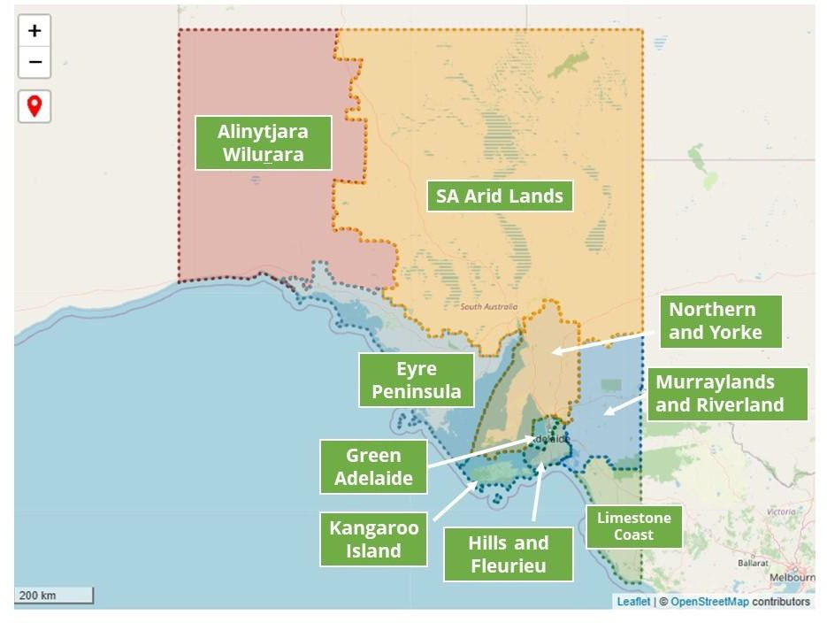
Landscapes Region Map

